UNITED STATES SECURITIES AND EXCHANGE COMMISSION
Washington, D.C. 20549

SCHEDULE 14A
Proxy Statement Pursuant to Section 14(a) of the
Securities Exchange Act of 1934 (Amendment No.)

Filed by the Registrant ☒
Filed by a Party other than the Registrant ☐
Check the appropriate box:

☐ |  | Preliminary Proxy Statement
☐ |  | Confidential, for Use of the Commission Only (as permitted by Rule 14a-6(e)(2))
☐ |  | Definitive Proxy Statement
☒ |  | Definitive Additional Materials
☐ |  | Soliciting Material under §240.14a-12
Microsoft Corporation
(Name of Registrant as Specified In Its Charter)
(Name of Person(s) Filing Proxy Statement, if other than the Registrant)
Payment of Filing Fee (Check all boxes that apply):

☒ |  | No fee required

☐ |  | Fee paid previously with preliminary materials

☐ |  | Fee computed on table in exhibit required by Item 25(b) per Exchange Act Rules 14a-6(i)(1) and 0-11


Your Vote Counts! MICROSOFT CORPORATION 2026 Annual Meeting Vote by December 7, 2026 11:59 PM ET C/O PROXY SERVICES P.O. BOX 9163 FARMINGDALE, NY 11735 T03700-P56195 You invested in MICROSOFT CORPORATION and it’s time to vote! You have the right to vote on proposals being presented at the Annual Meeting. This is an important notice regarding the availability of proxy materials for the shareholder meeting to be held on December 8, 2026. Get informed before you vote View the Notice and Proxy Statement and Annual Report online OR you can receive a free paper or email copy of the material(s) by requesting prior to November 24, 2026. If you would like to request a copy of the material(s) for this and/or future shareholder meetings, you may (1) visit www.ProxyVote.com, (2) call 1-800-579-1639 or (3) send an email to sendmaterial@proxyvote.com. If sending an email, please include your control number (indicated below) in the subject line. Unless requested, you will not otherwise receive a paper or email copy. For complete information and to vote, visit www.ProxyVote.com Control # Smartphone users Vote Virtually at the Meeting* December 8, 2026 Point your camera here and 8:30 a.m. Pacific Time vote without entering a control number Virtually at: www.virtualshareholdermeeting.com/MSFT26 *Please check the meeting materials for any special requirements for meeting attendance.

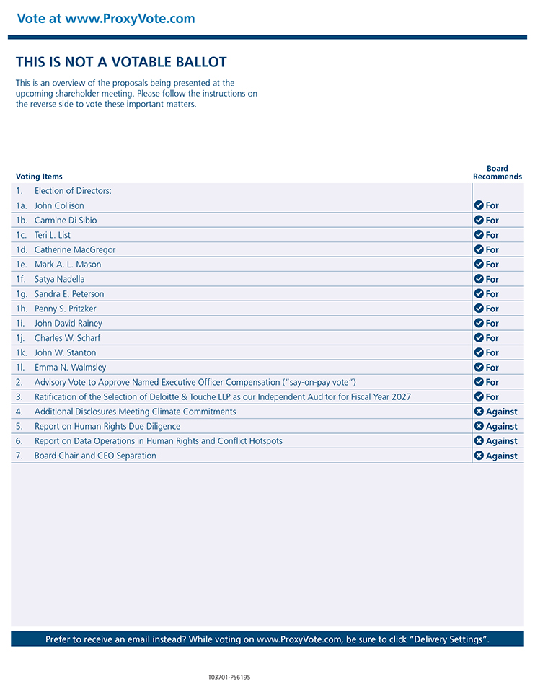
Vote at www.ProxyVote.com THIS IS NOT A VOTABLE BALLOT This is an overview of the proposals being presented at the upcoming shareholder meeting. Please follow the instructions on the reverse side to vote these important matters. Board Voting Items Recommends 1. Election of Directors: 1a. John Collison For 1b. Carmine Di Sibio For 1c. Teri L. List For 1d. Catherine MacGregor For 1e. Mark A. L. Mason For 1f. Satya Nadella For 1g. Sandra E. Peterson For 1h. Penny S. Pritzker For 1i. John David Rainey For 1j. Charles W. Scharf For 1k. John W. Stanton For 1l. Emma N. Walmsley For 2. Advisory Vote to Approve Named Executive Officer Compensation (“say-on-pay vote”) For 3. Ratification of the Selection of Deloitte & Touche LLP as our Independent Auditor for Fiscal Year 2027 For 4. Additional Disclosures Meeting Climate Commitments Against 5. Report on Human Rights Due Diligence Against 6. Report on Data Operations in Human Rights and Conflict Hotspots Against 7. Board Chair and CEO Separation Against Prefer to receive an email instead? While voting on www.ProxyVote.com, be sure to click “Delivery Settings”. T03701-P56195

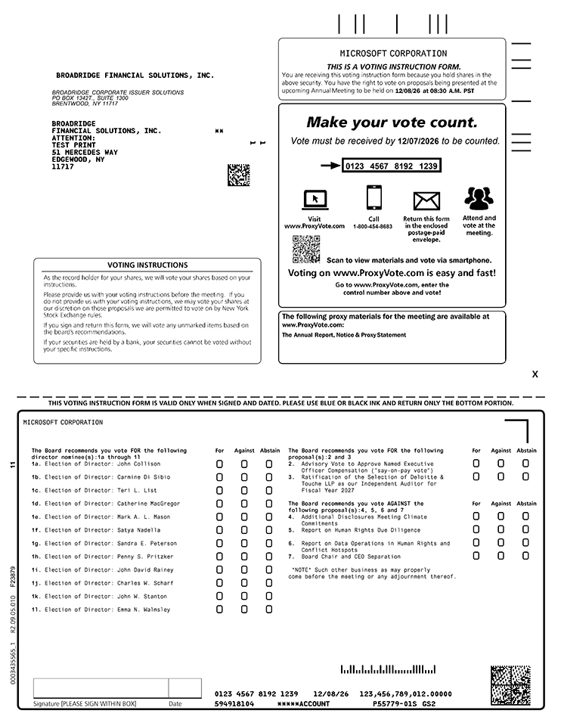
MICROSOFT CORPORATION 12/08/26 at 08:30 A.M. PST BROADRIDGE CORPORATE ISSUER SOLUTIONS PO BOX 1342T., SUITE 1300 BRENTWOOD, NY 11717 Vote must be received by 12/07/2026 to be counted. 0123 4567 8192 1239 1-800-454-8683 Scan to view materials and vote via smartphone. The following proxy materials for the meeting are available at www.ProxyVote.com: The Annual Report, Notice & Proxy Statement MICROSOFT CORPORATION F23879 11 MICROSOFT CORPORATION Scan to view materials and vote via smartphone. Vote must be received by 12/07/2026 to be counted. F23879 11 0123 4567 8192 1239 PAGE BROADRIDGE FINANCIAL SOLUTIONS, INC. IHPORTANT NOTICE REGARDING DELIVERY OF SECURITY HOLDER DOCUHENTS CHH) BROADRIDGE FINANCIAL SOLUTIONS, INC. ATTENTION: TEST PRINT 51 HERCEDES WAY EDGEWOOD, NY 11717 VOTING INSTRUCTIONS NN As the record holder for your shares, we will vote your shares based on your instructions. Please provide us with your voting instructions before the meeting. If you do not provide us with your voting instructions, we may vote your shares at our discretion on those proposals we are permitted to vote on by New York Stock Exchange rules. If you sign and return this form, we will vote any unmarked items based on the board’s recommendations. If your securities are held by a bank, your securities cannot be voted without your specific instructions. 1 OF 2 THIS IS A VOTING INSTRUCTION FORM. You are receiving this voting instruction form because you hold shares in the above security. You have the right to vote on proposals being presented at the upcoming Annual Meeting to be held on Make your vote count. Visit Call Return this form Attend and www.ProxyVote.com in the enclosed vote at the postage-paid meeting. envelope. Voting on www.ProxyVote.com is easy and fast! Go to www.ProxyVote.com, enter the control number above and vote! THIS VOTING INSTRUCTION FORM IS VALID ONLY WHEN SIGNED AND DATED. PLEASE USE BLUE OR BLACK INK AND RETURN ONLY THE BOTTOM PORTION. X 7 The Board recommends you vote FOR the following director nominee(s):1a through 11 1a. Election of Director: John Collison 1b. Election of Di rector: Carmine Di Sibio 1c. Election of Di rector: Teri L. List 1d. Election of Di rector: Catherine MacGregor 1e. Election of Di rector: Mark A. L. Mason 1f. Election of Di rector: Sat ya Nadell a 1g. Election of Di rector: Sandra E. Peterson 1h. Election of Di rector: Penny S. Pritzker 1i. Election of Di rector: John David Rainey 1j. Election of Di rector: Charles W. Scharf 1k. Election of Di rector: John W. Stanton 11. Election of Di rector: Emma N. Walmsley HOUSEHOLPING ELECTION - Please indicate if you consent to receive certain future investor contraindications in a single package per household. Signature [PLEASE SIGN WITHIN BOX] Date For Against Abstain The Board recommends you vote FOR the following proposal (s): 2 and 3 2. Advisory Vote to Approve Named Executive Officer Compensation (“say-on-pay vote”) 3. Ratification of the Selection of Deloitte & Touche LLP as our Independent Auditor for Fiscal Year 2027 The Board recommends you vote AGAINST the following proposal(s):4, 5, 6 and 7 4. Additional Disclosures Meeting Climate Commitments 5. Report on Human Rights Due Diligence 6. Report on Data Operations in Human Rights and Conflict Hotspots 7. Board Chair and CEO Separation “NOTE” Such other business as may properly come before the meeting or any adjournment thereof. Yes No 0123 4567 8192 1239 12/08/26 123,456,789,012.00000 594918104 P55779-01S GS2

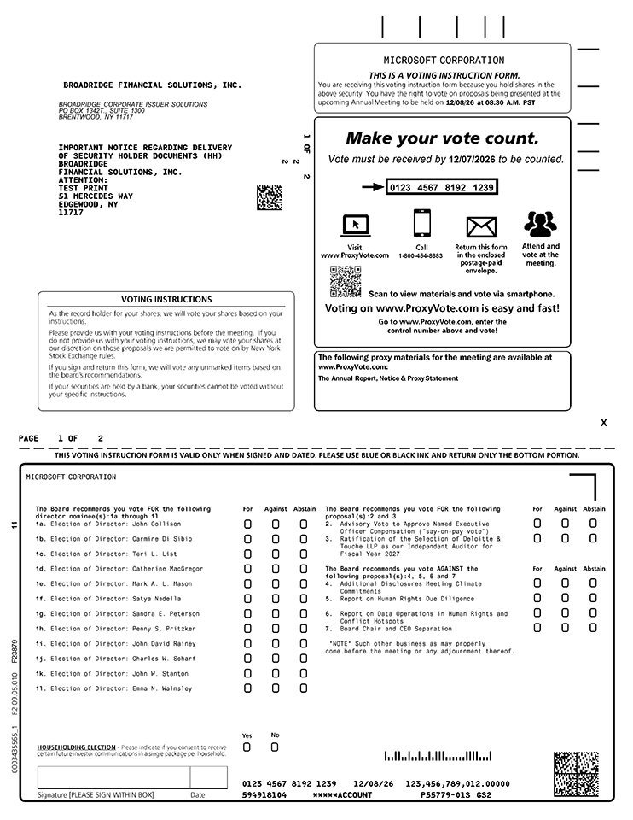
MICROSOFT CORPORATION 12/08/26 at 08:30 A.M. PST BROADRIDGE CORPORATE ISSUER SOLUTIONS PO BOX 1342T., SUITE 1300 BRENTWOOD, NY 11717 Vote must be received by 12/07/2026 to be counted. 0123 4567 8192 1239 1-800-454-8683 Scan to view materials and vote via smartphone. The following proxy materials for the meeting are available at www.ProxyVote.com: The Annual Report, Notice & Proxy Statement MICROSOFT CORPORATION F23879 11 BROADRIDGE FINANCIAL SOLUTIONS, INC. IHPORTANT NOTICE REGARDING DELIVERY OF SECURITY HOLDER DOCUHENTS CHH) BROADRIDGE FINANCIAL SOLUTIONS, INC. ATTENTION: TEST PRINT 51 HERCEDES WAY EDGEWOOD, NY 11717 VOTING INSTRUCTIONS NN As the record holder for your shares, we will vote your shares based on your instructions. Please provide us with your voting instructions before the meeting. If you do not provide us with your voting instructions, we may vote your shares at our discretion on those proposals we are permitted to vote on by New York Stock Exchange rules. If you sign and return this form, we will vote any unmarked items based on the board’s recommendations. If your securities are held by a bank, your securities cannot be voted without your specific instructions. 1 OF 2 THIS IS A VOTING INSTRUCTION FORM. You are receiving this voting instruction form because you hold shares in the above security. You have the right to vote on proposals being presented at the upcoming Annual Meeting to be held on Make your vote count. 181 Visit Call Return this form Attend and www.ProxyVote.com in the enclosed vote at the postage-paid meeting. envelope. Voting on www.ProxyVote.com is easy and fast! Go to www.ProxyVote.com, enter the control number above and vote! THIS VOTING INSTRUCTION FORM IS VALID ONLY WHEN SIGNED AND DATED. PLEASE USE BLUE OR BLACK INK AND RETURN ONLY THE BOTTOM PORTION. X 7 The Board recommends you vote FOR the following director nominee(s):1a through 11 1a. Election of Director: John Collison 1b. Election of Di rector: Carmine Di Sibio 1c. Election of Di rector: Teri L. List 1d. Election of Di rector: Catherine MacGregor 1e. Election of Di rector: Mark A. L. Mason 1f. Election of Di rector: Sat ya Nadell a 1g. Election of Di rector: Sandra E. Peterson 1h. Election of Di rector: Penny S. Pritzker 1i. Election of Di rector: John David Rainey 1j. Election of Di rector: Charles W. Scharf 1k. Election of Di rector: John W. Stanton 11. Election of Di rector: Emma N. Walmsley HOUSEHOLPING ELECTION - Please indicate if you consent to receive certain future investor contraindications in a single package per household. Signature [PLEASE SIGN WITHIN BOX] Date For Against Abstain The Board recommends you vote FOR the following proposal (s): 2 and 3 2. Advisory Vote to Approve Named Executive Officer Compensation (“say-on-pay vote”) 3. Ratification of the Selection of Deloitte & Touche LLP as our Independent Auditor for Fiscal Year 2027 The Board recommends you vote AGAINST the following proposal(s):4, 5, 6 and 7 4. Additional Disclosures Meeting Climate Commitments 5. Report on Human Rights Due Diligence 6. Report on Data Operations in Human Rights and Conflict Hotspots 7. Board Chair and CEO Separation “NOTE” Such other business as may properly come before the meeting or any adjournment thereof. Yes No 0123 4567 8192 1239 12/08/26 123,456,789,012.00000 594918104 P55779-01S GS2

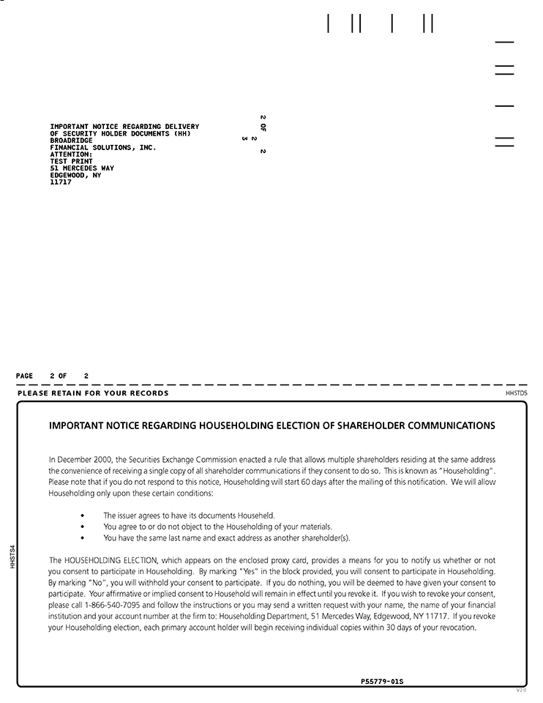
IMPORTANT NOTICE REGARDING DELIVERY OF SECURITY HOLDER DOCUMENTS CHHJ BROADRIDGE FINANCIAL SOLUTIONS, INC. ATTENTION: TEST PRINT 51 MERCEDES WAY EDGEWOOD, NY 11717 PAGE 2 OF 2 11 11 PLEASE RETAIN FOR YOUR RECORDS IMPORTANT NOTICE REGARDING HOUSEHOLDING ELECTION OF SHAREHOLDER COMMUNICATIONS In December 2000, the Securities Exchange Commission enacted a rule that allows multiple shareholders residing at the same address the convenience of receiving a single copy of all shareholder communications if they consent to do so. This is known as” Householding”. Please note that if you do not respond to this notice, Householding will start 60 days after the mailing of this notification. We will allow Householding only upon these certain conditions: The issuer agrees to have its documents Househeld. You agree to or do not object to the Householding of your materials. You have the same last name and exact address as another shareholder(s). The HOUSEHOLDING ELECTION, which appears on the enclosed proxy card, provides a means for you to notify us whether or not you consent to participate in Householding. By marking “Yes” in the block provided, you will consent to participate in Householding. By marking “No”, you will withhold your consent to participate. If you do nothing, you will be deemed to have given your consent to participate. Your affirmative or implied consent to Household will remain in effect until you revoke it. If you wish to revoke your consent, please call 1-866-540-7095 and follow the instructions or you may send a written request with your name, the name of your financial institution and your account number at the firm to: Householding Department, 51 Mercedes Way, Edgewood, NY 11717. If you revoke your Householding election, each primary account holder will begin receiving individual copies within 30 days of your revocation. P55779-01S HHSTS4

