UNITED STATES

SECURITIES AND EXCHANGE COMMISSION
WASHINGTON, DC 20549

FORM SD

SPECIALIZED DISCLOSURE REPORT

Microsoft Corporation

(Exact Name of Registrant as Specified in Its Charter)

Washington
(State or Other Jurisdiction
of Incorporation)
001-37845 | 91-1144442
(Commission | (IRS Employer
File Number) | Identification No.)
One Microsoft Way, Redmond, Washington | 98052-6399
(Address of Principal Executive Offices) | (Zip Code)
(425) 882-8080
(Registrant’s Telephone Number, Including Area Code)
(Former Name or Former Address, if Changed Since Last Report)

Check the appropriate box to indicate the rule pursuant to which this form is being filed, and provide the period to which the information in this form applies:

- Rule 13p-1 under the Securities Exchange Act (17 CFR 240.13p-1) for the period from January 1 to December 31, 2021.

Section 1 - Conflict Minerals Disclosure

Items 1.01 Conflict Minerals Disclosure and Report

Conflict Minerals Disclosure

A copy of Microsoft’s Conflict Minerals Report is provided as Exhibit 1.01 hereto and is publicly available at:

http://aka.ms/conflictmineralreport

Item 1.02 Exhibits

The Conflict Minerals Report required by Item 1.01 is filed as Exhibit 1.01 to this form SD.

Section 2 - Exhibits

Item 2.01 - Exhibits

Exhibit 1.01 - Conflict Minerals Report

SIGNATURE

Pursuant to the requirements of the Securities Exchange Act of 1934, the registrant has duly caused this report to be signed on its behalf by the undersigned hereunto duly authorized.

MICROSOFT CORPORATION
(Registrant)

Date: May 31, 2022 /s/ BRADFORD L. SMITH
Bradford L. Smith
President and Chief Legal Officer

Exhibit 1.01

MICROSOFT CORPORATION

CONFLICT MINERALS REPORT
FOR 2021 REPORTING YEAR

- INTRODUCTION

This Conflict Minerals Report (“CMR”) for MICROSOFT CORPORATION (“Microsoft”) is filed with the United States Securities and Exchange Commission (SEC) as an exhibit to Microsoft’s Form SD pursuant to Rule 13p-1 under the Securities Exchange Act of 1934, as amended, (the “Rule”) for the 2021 Reporting Year (January 1, 2021-December 31, 2021).1 The CMR covers all Microsoft majority-owned subsidiaries and variable interest entities that are subject to the Rule.2 During the 2021 Reporting Year, covered devices included the Surface line of computers, tablets, mobile phones, and accessories; Xbox gaming consoles and accessories; personal computing accessories (mice, headsets, and keyboards); HoloLens mixed reality device; and service, spare, and replacement parts.

Our commitment to the responsible sourcing of raw materials is established by Microsoft’s Responsible Sourcing of Raw Materials (“RSRM”) Policy, which guides our work to ensure that all raw materials used in our devices, unbounded by specific materials or locations, are sourced from responsible suppliers. We commit to the responsible sourcing of tin, tantalum, tungsten and gold (“3TGs”) from Conflict Affected and High-Risk Areas (“CAHRAs”), including the Democratic Republic of the Congo (“DRC”) or DRC-adjoining countries (each a “Covered Country” under the Rule), rather than restricting or avoiding sourcing from such regions. We do this in in recognition of the harmful societal and economic impacts that curtailing 3TG mineral sourcing from such regions might cause.

Based on our supply chain due diligence, we determined that 3TGs that were necessary to the functionality or production of devices we manufactured or contracted to manufacture during the 2021 Reporting Year may have originated in a Covered Country. Microsoft found no reasonable basis for concluding that any 3TG Smelter or Refiner (“SOR”) that was identified in Microsoft Devices supply chain for the 2021 Reporting Year sourced 3TGs in a manner that directly or indirectly financed or benefitted armed groups in a Covered Country.

- This CMR contains links to internal and external websites for informational purposes only. References to such websites and information available through such websites are not incorporated into this CMR. Additionally, this CMR includes forward-looking statements within the meaning of the Private Securities Litigation Reform Act of 1995. These forward-looking statements are based on current expectations and assumptions regarding the future implementation of our responsible sourcing program and are subject to change. Statements in this CMR

are based on due diligence activities that were performed in good faith and to the best of our ability at the time of this filing. Factors that could affect the accuracy of such statements include, but are not limited to, incomplete or incorrect data submitted by suppliers, amendments to the Rule or SEC guidance.

- Throughout this CMR, we use “Microsoft,” “Microsoft Devices,” “we,” “our,” “us” and similar terms to refer to Microsoft Corporation and its subsidiaries and various interest entities subject to the Rule (collectively, “Microsoft”), unless otherwise indicated.

1

- DUE DILIGENCE FRAMEWORK

This CMR is based on Microsoft Devices’ Due Diligence Framework (“Due Diligence Framework”), which conforms to the Organisation for Economic Co-operation and Development (“OECD”) Due Diligence Guidance for Responsible Supply Chains of Minerals from Conflict-Affected and High-Risk Areas and its related Supplements (“OECD Guidance”).

Our Devices supply chain contains many layers of upstream suppliers positioned between Microsoft and 3TG raw material mines and SORs. We use contractual provisions to require our direct suppliers to disclose information through an industry standard Conflict Mineral Reporting Template (CMRT) and meet audit requirements regarding the sources and chains of custody of 3TGs necessary for the functionality or production of our covered devices. We also require our direct suppliers to pass Microsoft requirements regarding 3TG sources and chains of custody to their direct suppliers. In this manner, we work to promote responsible sourcing across our direct and indirect supply chains.

Our due diligence actions go beyond the Rule and OECD Guidance by including several quality assurance steps. We engage with a third party to review all supplier responses to validate 3TG sourcing data. If a non-conformant SOR is reported by a supplier, we work with the supplier to engage with the SOR to bring them into conformance. If the SOR is not interested or not able to become conformant, we instruct suppliers to remove the SOR from their supply chain and source from conformant alternatives or face business termination with Microsoft.

We also survey our supply chain for minerals beyond 3TGs and beyond the Covered Countries consistent with our Responsible Souring of Raw Materials (RSRM) Policy, which is unbounded by specific materials or location. In addition to the CMRT survey, which is focused on 3TGs, we require our in-scope suppliers to report on their use of cobalt and other priority minerals, including aluminum, copper, lithium, magnesium, and nickel.

- Step #1: Establish Strong Company Management Systems

- Company Policies

Microsoft’s commitment to corporate responsibility and integrity guides everything we do as a company. We have established high ethical standards to govern the way we conduct our business, which also apply to our suppliers and business partners. Microsoft policies include the Microsoft Global Human Rights Statement, Trust Code, and our Supplier Code of Conduct. These policies establish Microsoft expectations our suppliers concerning legal and regulatory compliance; business practices and ethics; human rights and fair labor practices; health and safety; environmental protection; and data and privacy protection.

As previously described, our RSRM Policy describes our commitment to responsibly source raw materials. This pledge extends to the harvesting, extraction, and transportation of raw materials unbounded by specific material or location. This policy supports implementation of programs that advance the use of responsibly sourced minerals in our manufactured devices

2

Our policies are based on internationally recognized standards, including the following declaration and covenants: Universal Declaration of Human Rights, International Covenant on Civil and Political Rights, and International Covenant on Economic, Social and Cultural Rights. Our business operations are informed by human rights guidelines described in the following documents: International Labour Organization’s (“ILO”) Declaration on Fundamental Principles and Rights at Work, OECD Guidelines for Multinational Enterprises, and the United Nations Global Compact. As a global Information and Communications Technology company operating in more than 100 countries, we respect all human rights - civil, political, economic, social, and cultural; and our supplier requirements expect the same level of commitment.

- Internal Management Team and Corporate Approval

A cross-functional internal team supports CMR development. Microsoft’s Senior Director of Devices Responsible Sourcing sponsors the team, which consists of representatives from Devices Manufacturing and Sourcing; Responsible Sourcing; Corporate, External and Legal Affairs; Information Services; Product Environmental Compliance; Global Trade; Finance; and Public Relations. The team assesses program progress, identifies steps needed to meet our compliance obligations, and identifies areas for continuous improvement. The team annually develops, reviews, and submits the final CMR to Microsoft’s President for approval and signature before being filed as an Exhibit to Microsoft’s Form SD and posted on the Microsoft website pursuant to the Rule.

- System of Supply Chain Controls, Data Disclosure, and Due Diligence Assurance

Our Due Diligence Framework is based on a system of supply chain controls, data disclosure, and due diligence assurance. We require our suppliers to meet Microsoft specifications through our contracts. Our environmental product compliance specifications - H00594, Restricted Substances for Hardware Products; and H00642, Microsoft Restricted Substances Control System for Hardware Products (both available at this link) - require the disclosure of every substance contained in the materials, components, and products supplied to us, including 3TGs, by weight.

We require suppliers to annually submit a CMRT, providing source and chain of custody information for 3TGs that are contained in the products and components they supply to us. Our contracts also require suppliers to obtain the same information from their upstream suppliers. We collect these supply chain disclosures, conduct controls to ensure data integrity, and assess 3TG sourcing risk. Microsoft investigates any potential nonconformances and engages with suppliers that fail to meet Microsoft specifications and requirements.

Microsoft supply chain mineral disclosure requirements go beyond 3TGs and cover additional prioritized minerals. Since 2019, we have required suppliers to report on their use of cobalt, using the Responsible Minerals Initiative’s Extended Minerals Reporting Template. In 2020, we expanded our due diligence requirements, collecting data on aluminum, copper, lithium, magnesium, and nickel using the Microsoft Material Reporting Template.

Microsoft Devices’ Supplier Social and Environmental Accountability Manual (“H02050”) provides an operational framework for Microsoft to achieve supplier conformance with the Supplier Code of

3

Conduct and other responsible sourcing requirements. H02050 establishes a minimum set of requirements that suppliers must meet, including compliance with all applicable laws and regulations with respect to labor, ethics, occupational health and safety, and protection of the environment. Suppliers are encouraged to go beyond legal compliance by meeting relevant international standards (i.e., ILO and relevant United Nations Conventions) and committing to a process of continuous improvement.

H02050 requires all in-scope suppliers to:

- Adopt a company policy for raw material sourcing, including a commitment to source raw materials from responsible sources and clearly communicate such policy to their suppliers and the public;

- Exercise due diligence on the source and chain of custody of high-risk raw materials, including 3TGs, contained in materials, products, or parts supplied to Microsoft;

- Require those SORs to participate in the Responsible Mining Assurance Program (“RMAP”) or an equivalent independent, third-party audit program for 3TGs; and

- Timely communicate potential sourcing risks to Microsoft and propose a contingency plan and mitigation strategy to achieve conformance.

Suppliers are required to establish a system to gather, examine, and verify sourcing information for raw materials, including 3TGs, contained in products supplied to Microsoft and request their upstream suppliers to do the same. This supply chain transfer of audit data, source and chain of custody information, and risk assessment enables and facilitates raw material due diligence, mapping, and transparency.

Microsoft works with its suppliers to use SORs that are conformant to RMAP or another equivalent independent, third-party audit program for 3TGs. If we find that a supplier has introduced responsible sourcing risk to the Microsoft supply chain, such as use of an upstream SOR that is not conformant, Microsoft engages with such supplier to address the non-conformance. Risks are mitigated by supplier engagement, corrective actions, audits, training, and business termination when appropriate. These controls and related documentation are detailed in H02050 and Microsoft internal operating procedures.

- Leveraging Industry Partnerships for Greater Impact

We leverage partnerships with industry peers and partners to scale our responsible sourcing impact. Microsoft is a long-standing member of the Responsible Business Alliance (“RBA”), and chairs its Responsible Minerals Initiative (RMI) Steering Committee. The RMI is one of the most utilized and respected resources for supply chain minerals due diligence and is aligned to the OECD Guidance. The RMI operates and manages the Responsible Minerals Assurance Process (RMAP), which uses independent, third-party audits to assess, monitor, and validate whether SORs process 3TGs from sources that directly or indirectly finance or benefit armed groups in a CAHRA, including Covered Countries.

4

In 2021, Microsoft provided direct financial support to the RMI upstream smelter due diligence fund to further the reach and success of the RMAP. Microsoft also supported the development of an RMI toolkit that provides due diligence guidance for mineral supply chains beyond 3TG and cobalt. This guidance will help suppliers conduct due diligence on a broader range of critical minerals, aligning with Microsoft’s expanded supply chain disclosure requirements for aluminum, copper, lithium, magnesium, and nickel.

We also work outside of our supply chain to promote responsible mining practices in CAHRAs, including Covered Countries, by partnering with organizations, including the RMI, the Initiative for Responsible Mining Assurance (“IRMA”), the Public-Private Alliance for Responsible Minerals Trade (“PPA”), and others. In this manner, we go beyond the minimum due diligence established by the OECD Guidance to assess and reduce our supply chain sourcing risk and improve working conditions in raw material supply chains.

- Supplier Engagement to Ensure Conformance

We apply several supplier-focused strategies to promote responsible mining and sourcing, including the supplier engagement tools set forth below.

- Supplier Requirements: We require our suppliers to meet our material disclosure requirements and related responsible sourcing policies through contractual provisions and product specifications. We communicate, monitor, and track supplier adherence to these requirements, ensuring conformance through the Microsoft Audit Management System (“AMS”) and maintain supplier records for a minimum of five years.

- Training: We train suppliers on our responsible sourcing requirements through classes, educational forums, and direct communications. The SEA Academy is part of the supplier on-boarding process. Existing suppliers and newly onboarded suppliers are required to complete training modules to understand and implement Microsoft SEA requirements. We leverage the online component of our “SEA Academy” to educate factory management, workers, and third-party auditors as well as internal Microsoft teams with the goal of promoting responsible sourcing across our supply chain.

- Capability Building and Partnerships: We work closely with in-scope suppliers and third-party auditors to build suppliers’ raw material due diligence capabilities and advance conformance to the RMAP or equivalent independent, third-party audit program for 3TGs. We invest in industry programs to increase suppliers’ abilities and provide platforms for sharing best practices.

- Supplier Audits and Conformance Assurance: Microsoft requires audits of its directly contracted suppliers to assess their conformance to these requirements. Newly contracted suppliers undergo an Initial Capability Assessment (“ICA”) prior to onboarding and Sustaining Maintenance Audits (“SMA”) after onboarding to verify their initial conformance and to confirm their sustained conformance to our requirements.

5

Microsoft selects and retains business partners that have committed to meet these requirements. A failure by a supplier or their upstream suppliers to conform to these requirements may constitute a breach of the supplier’s contractual agreement with Microsoft, resulting in possible business termination

- Grievance Mechanism

Microsoft provides an anonymous grievance reporting mechanism for employees and other stakeholders who may be impacted by our operations. Microsoft’s Business Conduct Hotline allows employees and others to anonymously ask compliance questions or report concerns regarding Microsoft’s business operations, including our responsible sourcing policies or those of our suppliers. Additionally, Microsoft continues to scale its Worker Voice Hotline Program3 across our supplier factories. This program provides workers with a reliable and anonymous reporting channel for raising workplace concerns. The Hotline is operated by a neutral third-party provider. We investigate and, where appropriate, take remedial action to address reported issues. We also participate in the development of industry grievance mechanisms that seek to address responsible sourcing of raw materials related issues.

- Step #2: Identify and Assess Risk in the Supply Chain

In order to make a Reasonable Country of Origin Inquiry (“RCOI”) determination, Microsoft took the following steps, which are consistent with
OECD Guidance and Microsoft procedure, to identify and assess 3TG sourcing risk in our supply chain during the 2021 Reporting Year:

- We generated a list of in-scope suppliers by surveying 193 Devices direct suppliers to determine whether they used any 3TGs in the products or parts supplied to Microsoft by utilizing the CMRT and the services of a third-party solution provider. All suppliers responded to our survey request – a 100% response rate.

- We excluded suppliers that did not report the use of 3TGs in the products or parts supplied to Microsoft during the 2021 Reporting Year from our in-scope supplier list.

- For the 2021 Reporting Year, we identified 148 in-scope suppliers that reported the use of 3TGs in the products or parts supplied to Microsoft. For these suppliers, we reviewed their CMRT responses to validate completion and to identify any contradictions or inconsistencies. We worked with our third-party solution provider to obtain updated or missing information when necessary.

- Please see page 60 of our 2021 Devices Responsible Sourcing Report for more details regarding our Workers’ Voice Hotline Program.

6

- Based on the CMRTs, 322 SORs were found to be eligible for the RMAP or an equivalent, independent, third-party audit program for 3TGs such as cross-recognized programs overseen by the London Bullion Market Association (“LBMA”) or Responsible Jewellery Council (“RJC”).

Figure 1. CMRT Response Rate (2013-2021 Reporting Years)
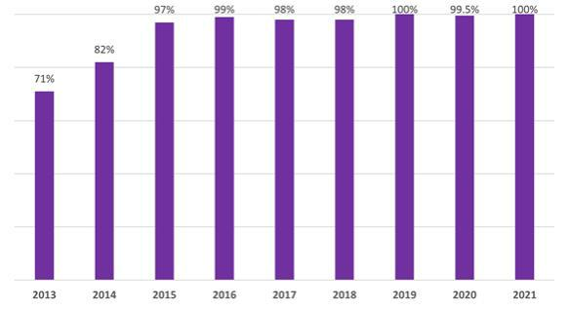

- Step #3: Design and Implement a Strategy to Respond to Risks

We determined that 3TGs that were necessary to the functionality or production of covered devices may have originated in one or more Covered Country. Accordingly, we performed due diligence on the source and chain-of-custody of those 3TGs to assess our conflict minerals sourcing risk.

- Microsoft Supplier Specifications—H00594, H00642, and H02050

For the 2021 Reporting Year, Microsoft required its in-scope suppliers to conduct due diligence to address the potential sourcing of 3TGs from CAHRAs, including Covered Countries, through contract requirements (H00594, H00642, and H02050), incorporating Microsoft’s supplier specifications and responsible sourcing requirements, as detailed above.

7

- Implementation of OECD Guidance

Microsoft screened its in-scope supplier CMRT data for the 2021 Reporting Year against the OECD Guidance” red flag” triggers4 to assess the in-scope suppliers that required due diligence per the OECD Guidance.

- Step #4: Independent Third-Party Audits of Supply Chain Due Diligence

Our due diligence program leveraged independent SOR audits to provide assurance that the 322 3TG SORs that were identified in our supply chain for the 2021 Reporting Year conducted an appropriate level of conflict minerals due diligence. Microsoft obtained SOR data from the RMAP Conformant Smelter List5 using Reasonable Country of Origin Inquiry Data for member MSFT and used the SOR data to assess the conflict mineral audit status of our in-scope suppliers and to support our due diligence findings.

Recognizing the importance of broad and consistent participation in the RMAP program, Microsoft proactively engages directly with certain SORs where it is believed that a SOR may be at risk of becoming non-conformant. Microsoft also asks its suppliers to engage directly with potentially non-conformant SORs in order to prevent potential non-conformance and to develop Corrective Action Plans (“CAPs”) to identify sourcing alternatives in case a SOR become non-conformant.

Although Microsoft’s Responsible Sourcing program operates an escalation and engagement process should non-conformant SORs be detected, taking a proactive approach to potentially non-conformant SORs helps prevent potential non-conformances from occurring. During the 2021 Reporting Year, we did not identify a SOR nonconformance that supported business termination with any in-scope supplier.

- Step #5: Report on Supply Chain Due Diligence

We have filed our CMR with the SEC and concurrently posted it on our Microsoft Devices Responsible Sourcing website. The results of our Responsible Sourcing program are also presented in Microsoft’s 2021 Devices Responsible Sourcing Report. The Microsoft Corporate Social Responsibility Responsible Sourcing website provides additional information about Microsoft’s RSRM Program. Each year, Microsoft Devices publishes a list of its Top 100 Production Suppliers. These disclosures meet the fifth step of the OECD Guidance.

- CONFLICT MINERAL DISCLOSURE

- Reasonable Countries of Origin of 3TGs

Microsoft obtained Reasonable Country of Origin data through our membership in the RMAP using the Reasonable Country of Origin Inquiry Data for member MSFT. We used this data to determine the 3TG country of origin for the 322 Eligible SORs identified in Microsoft Devices’ supply chain for the 2021 Reporting Year.

- See p. 33 of the OECD Guidance.

- The RMAP Conformant Smelter list identifies the SORs that have undergone conformance audits through the RMAP or equivalent independent, third-party audit programs for 3TGs.

8

The RMAP classifies SOR audit status in the manner described in the table below. The breakdown of the identified 322
Eligible 3TG SORs (for which minerals sourcing information was available from RMAP or an equivalent, independent, third-party audit program for 3TGs) by their RMI Status was as follows:

Audit Status |  | Audit Status Description |  |  | SORs |  | % | %
Conformant |  |  | SOR has been audited and found to conform with a relevant, third-party audit protocol, |  | 238 |  | 73.9 | %
 |  | including RMAP, London Bullion Market Association (“LBMA”), or Responsible Jewellery
Active |  | Council (“RJC”)
 |  | SOR has been engaged but is not yet conformant |  |  | 25 |  | 7.8%
Non-Conformant |  | SOR was audited but found not to conform to a relevant, third-party audit protocol or failed to |  |  | 9 |  | 2.8%
Communication |  | renew its assessment |  |  | 5 |  | 1.6%
Suspended |  | Not Interested: SOR has strongly communicated a lack of interest in participation
Outreach Required |  | SOR is not yet active and outreach is needed by RMAP member companies to encourage SOR |  |  | 36 |  | 11.2%
In Communication |  | participation in RMAP
 |  | SOR is not yet active but is in communication with RMAP and/or member company |  |  | 5 |  | 1.6%
RMI Due Diligence |  | Unable to Proceed: SOR has not met the threshold for Due Diligence Vetting Process after a |  |  | 4 |  | 1.2%
Review |  | period of 6 months. Status may change if additional information is submitted
 |  | 9

For the identified 322 Eligible 3TG SORs:

- 48 SORs sourced from Covered Countries, of which 46 (95.8%) were Conformant and 2 (4.2%) were Active;

- For these 48 SORs, the audit status per 3TG mineral was 100% Conformant for Gold, Tantalum, and Tungsten and 80% Conformant and 20% Active for Tin (see Figure 3 below).

- Out of 322 Eligible SORs, 238 (73.9%) were Conformant; and

- Out of 322 Eligible SORs, 309 (96.0%) were Conformant, Active, or are reasonably believed to have sourced 3TGs from outside the Covered Countries.

Microsoft found no reasonable basis for concluding that any SOR sourced 3TGs in a manner that directly or indirectly financed or benefitted armed groups in a Covered Country. Figure 2 depicts the 322 SORs by 3TG audit status and Reporting Year. Figure 3 depicts the audit status of the 48 SORs that sourced 3TGs from a Covered Country by 3TG mineral for the 2021 Reporting Year.

Figure 2. Identified SORs by Audit Status (2013- 2021 Reporting Years)
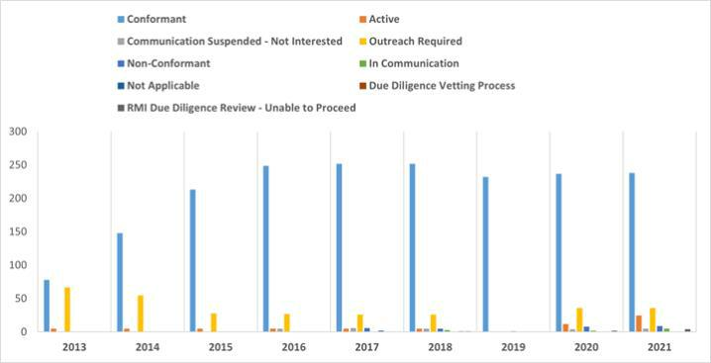

10

Figure 3: Audit Status of SORs Sourcing from Covered Countries by 3TG Mineral
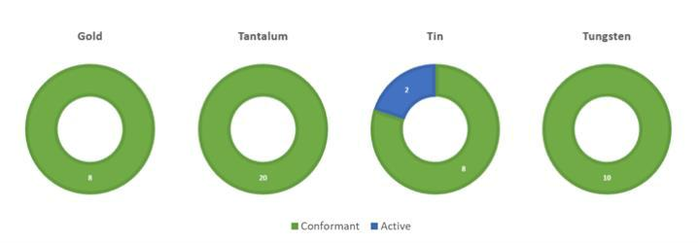

Figures 4-7 show the geographic distribution of the 322 Eligible SORs identified in the Microsoft Devices’ supply chain by 3TG mineral for the 2021 Reporting Year. The circle size corresponds to the relative number of times our in-scope suppliers identified each 3TG SOR in their CMRT form.

Figure 4: Location and Relative Number of Identified SORs – Tin
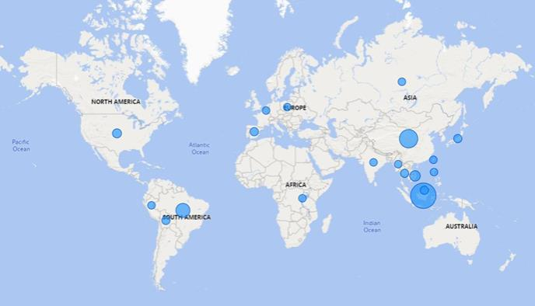

11

Figure 5: Location and Relative Number of Identified SORs – Tantalum
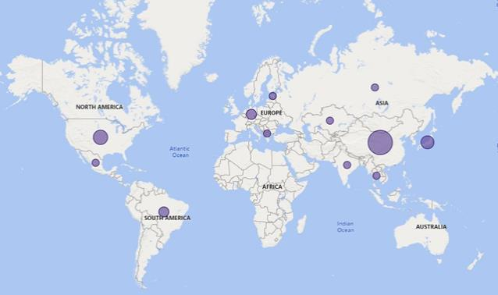

Figure 6: Location and Relative Number of Identified SORs – Tungsten
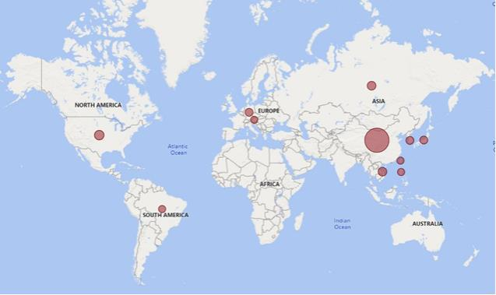

12

Figure 7: Location and Relative Number of Identified SORs – Gold
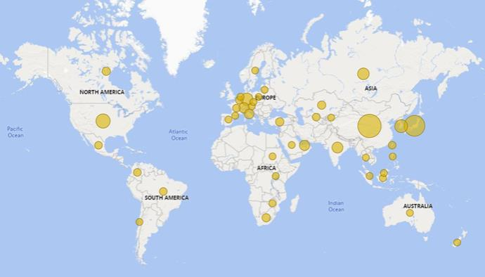

Appendix A provides the list of 322 Eligible SORs identified in Microsoft Devices’ supply chain which processed 3TGs during the 2021 Reporting Year. Appendix A lists each SOR by mineral, official name, and country of operation.

- 3TG Countries of Origin

The table below lists the countries of origin for the 322 Eligible SORs identified in Microsoft Devices’ supply chain which processed 3TGs during the 2021 Reporting Year.

Angola
Argentina
Armenia
Australia
Austria
Belarus
Belgium
Bolivia
Brazil
Burundi
Cambodia
Canada

Central African Republic

Luxembourg
Madagascar
Malaysia
Mali
Mexico
Mongolia
Morocco
Mozambique
Myanmar
Namibia
Netherlands
New Zealand

Niger

13

Chile
China
Colombia
Republic of the Congo
Czech Republic
Djibouti
Democratic Republic of the Congo

Ecuador
Egypt
Estonia
Ethiopia
Finland
France
Germany
Ghana
Guinea
Guyana
Hong Kong
Hungary
India
Indonesia
Ireland
Israel
Italy
Ivory Coast
Japan
Kazakhstan
Kenya
Republic of Korea
Kyrgyzstan

Laos

Nigeria
Papua New Guinea
Peru
Philippines
Poland
Portugal
Russian Federation
Rwanda
Saudi Arabia
Sierra Leone
Singapore
Slovakia
South Africa
South Sudan
Spain
Suriname
Sweden
Switzerland
Taiwan
Tajikistan
Tanzania
Thailand
Turkey
Uganda
United Arab Emirates
United Kingdom
United States
Uzbekistan
Viet Nam
Zambia
Zimbabwe

IV. MICROSOFT COMMITMENT

Microsoft is committed to the responsible sourcing of raw materials in support of human rights; labor, health and safety; and environmental protection. We continue to advance implementation of our RSRM policy in our Devices supply chain to promote supply chain identification, traceability, risk assessment, and due diligence.

Our 2021 Reporting Year achievements included the following:

- We supported supplier efforts to increase their responsible sourcing capabilities through supplier forums, training, webinars, and by providing technical resources;

14

- We continued our engagements with external responsible sourcing organizations, including but not limited to the RMI, that are committed to advancing responsible sourcing on a global basis;

- We achieved a 100% supplier CMRT response rate through extensive supplier outreach, including a supplementary campaign to directly contact suppliers to encourage reporting;

- We conducted a data validation and verification program to randomly audit CMRT information submitted to us by suppliers to validate and confirm that supplier data was accurate and complete;

- We expanded due diligence program across all in-scope suppliers to capture sourcing data on additional priority minerals including aluminum, cobalt, copper, lithium, magnesium, and nickel.

Going forward, Microsoft will remain focused on internal and external efforts to promote the responsible sourcing of minerals from CAHRAs, including Covered Countries, including:

- Expanding our knowledge about 3TGs, cobalt, and other critical raw materials to effectively implement our RSRM strategy to promote the responsible sourcing of raw materials across our hardware supply chains;

- Requiring our in-scope suppliers to meet our requirements for responsibly sourcing raw materials and finding alternative upstream suppliers if they are found to be sourcing from non-conformant SORs;

- Engaging with in-scope suppliers so that they utilize supplier best practices and tools for responsibly sourcing raw materials from CAHRAs, including Covered Countries;

- Furthering engagement with industry organizations and external stakeholders to improve mineral traceability, establish global responsible sourcing standards, and support due diligence programs in the mineral supply chain;

- Leveraging Full Material Disclosure and other supplier data to fine-tune supplier data requests and verify and confirm reported critical raw material information; and

- Supporting the efforts of the RMI in developing the Minerals Agnostic Standard and Pilot Reporting Template (“PRT”), anticipated to be released in late 2022, which will provide a platform to collect data on all minerals, thus significantly expanding the scope of industry-wide minerals due diligence.

15

APPENDIX A

Eligible SORs for 2021 Reporting Year

This Appendix lists the 322 Eligible SORs which processed 3TGs during the 2021 Reporting Year. Please note that Eligible SORs are listed for each 3TG they processed. Therefore, certain Eligible SORs may be represented more than once.

Metal |  | Official Smelter Name |  | Smelter Country
Gold |  | Matsuda Sangyo Co., Ltd. |  | Japan
Gold |  | Ogussa Osterreichische Gold- und Silber-Scheideanstalt GmbH | Austria
Gold |  | Singway Technology Co., Ltd. | Taiwan
Gold |  | 8853 S.p.A. | Italy
Gold |  | Metalurgica Met-Mex Penoles S.A. De C.V. | Mexico
Gold |  | SOE Shyolkovsky Factory of Secondary Precious Metals | Russian Federation
Gold |  | Solar Applied Materials Technology Corp. | Taiwan
Gold |  | Metal Concentrators SA (Pty) Ltd. | South Africa
Gold |  | Refinery of Seemine Gold Co., Ltd. | China
Gold |  | Advanced Chemical Company | United States
Gold |  | Metalor Technologies (Hong Kong) Ltd. | China
Gold |  | Metalor Technologies (Singapore) Pte., Ltd. | Singapore
Gold |  | Metalor Technologies (Suzhou) Ltd. | China
Gold |  | Metalor Technologies S.A. | Switzerland
Gold |  | Metalor USA Refining Corporation | United States
Gold |  | Asahi Refining Canada Ltd. | Canada
Gold |  | Aida Chemical Industries Co., Ltd. | Japan
Gold |  | Geib Refining Corporation | United States
Gold |  | Degussa Sonne / Mond Goldhandel GmbH | Germany
Gold |  | L’Orfebre S.A. | Andorra
Gold |  | Al Etihad Gold Refinery DMCC | United Arab Emirates
Gold |  | Pease & Curren | United States
Gold |  | SAAMP | France
Gold |  | Allgemeine Gold-und Silberscheideanstalt A.G. | Germany
Gold |  | Industrial Refining Company | Belgium
Gold |  | Almalyk Mining and Metallurgical Complex (AMMC) | Uzbekistan
Gold |  | Sudan Gold Refinery | Sudan
Gold |  | Mitsubishi Materials Corporation | Japan
Gold |  | Mitsui Mining and Smelting Co., Ltd. | Japan
Gold |  | MMTC-PAMP India Pvt., Ltd. | India
Gold |  | Sumitomo Metal Mining Co., Ltd. | Japan
Gold |  | Morris and Watson | New Zealand
Gold |  | Moscow Special Alloys Processing Plant | Russian Federation
Gold |  | AngloGold Ashanti Corrego do Sitio Mineracao | Brazil
Gold |  | Nadir Metal Rafineri San. Ve Tic. A.S. | Turkey
Gold |  | Guangdong Jinding Gold Limited | China
 |  | A-1

Gold | T.C.A S.p.A | Italy
Gold | African Gold Refinery | Uganda
Gold | Argor-Heraeus S.A. | Switzerland
Gold | Asahi Pretec Corp. | Japan
Gold | Asaka Riken Co., Ltd. | Japan
Gold | Bangalore Refinery | India
Gold | Navoi Mining and Metallurgical Combinat | Uzbekistan
Gold | Tanaka Kikinzoku Kogyo K.K. | Japan
Gold | Atasay Kuyumculuk Sanayi Ve Ticaret A.S. | Turkey
Gold | GCC Gujrat Gold Centre Pvt. Ltd. | India
Gold | Aurubis AG | Germany
Gold | Hunan Guiyang yinxing Nonferrous Smelting Co., Ltd. | China
Gold | Nihon Material Co., Ltd. | Japan
Gold | Bangko Sentral ng Pilipinas (Central Bank of the Philippines) | Philippines
Gold | Hangzhou Fuchunjiang Smelting Co., Ltd. | China
Gold | Great Wall Precious Metals Co., Ltd. of CBPM | China
Gold | Shandong Gold Smelting Co., Ltd. | China
Gold | International Precious Metal Refiners | United Arab Emirates
Gold | QG Refining, LLC | United States
Gold | LT Metal Ltd. | Republic of Korea
Gold | Heimerle + Meule GmbH | Germany
Gold | Planta Recuperadora de Metales SpA | Chile
Gold | Heraeus Metals Hong Kong Ltd. | China
Gold | Boliden AB | Sweden
Gold | Heraeus Precious Metals GmbH & Co. KG | Germany
Gold | Tokuriki Honten Co., Ltd. | Japan
Gold | Tongling Nonferrous Metals Group Co., Ltd. | China
Gold | TOO Tau-Ken-Altyn | Kazakhstan
Gold | Torecom | Republic of Korea
Gold | C. Hafner GmbH + Co. KG | Germany
Gold | Ohura Precious Metal Industry Co., Ltd. | Japan
Gold | OJSC Novosibirsk Refinery | Russian Federation
Gold | Caridad | Mexico
Gold | OJSC “The Gulidov Krasnoyarsk Non-Ferrous Metals Plant”
 | (OJSC Krastsvetmet) | Russian Federation
Gold | CCR Refinery—Glencore Canada Corporation | Canada
Gold | Cendres + Metaux S.A. | Switzerland
Gold | Umicore Precious Metals Thailand | Thailand
Gold | Umicore S.A. Business Unit Precious Metals Refining | Belgium
Gold | Hunan Chenzhou Mining Co., Ltd. | China
Gold | PAMP S.A. | Switzerland
Gold | United Precious Metal Refining, Inc. | United States
Gold | Penglai Penggang Gold Industry Co., Ltd. | China
Gold | HwaSeong CJ Co., LTD. | Republic of Korea
Gold | Chimet S.p.A. | Italy
 | A-2

Gold | Valcambi S.A. | Switzerland
Gold | Inner Mongolia Qiankun Gold and Silver Refinery Share Co.,
 | Ltd. | China
Gold | Prioksky Plant of Non-Ferrous Metals | Russian Federation
Gold | Chugai Mining | Japan
Gold | PT Aneka Tambang (Persero) Tbk | Indonesia
Gold | Western Australian Mint (T/a The Perth Mint) | Australia
Gold | Ishifuku Metal Industry Co., Ltd. | Japan
Gold | Istanbul Gold Refinery | Turkey
Gold | Italpreziosi | Italy
Gold | WIELAND Edelmetalle GmbH | Germany
Gold | Japan Mint | Japan
Gold | CGR Metalloys Pvt Ltd. | India
Gold | Dijllah Gold Refinery FZC | United Arab Emirates
Gold | Sovereign Metals | India
Gold | C.I Metales Procesados Industriales SAS | Colombia
Gold | Jiangxi Copper Co., Ltd. | China
Gold | PX Precinox S.A. | Switzerland
Gold | Daye Non-Ferrous Metals Mining Ltd. | China
Gold | Yamakin Co., Ltd. | Japan
Gold | Guoda Safina High-Tech Environmental Refinery Co., Ltd. | China
Gold | Rand Refinery (Pty) Ltd. | South Africa
Gold | NH Recytech Company | Republic of Korea
Gold | Eco-System Recycling Co., Ltd. North Plant | Japan
Gold | Eco-System Recycling Co., Ltd. West Plant | Japan
Gold | DSC (Do Sung Corporation) | Republic of Korea
Gold | Asahi Refining USA Inc. | United States
Gold | DODUCO Contacts and Refining GmbH | Germany
Gold | Yokohama Metal Co., Ltd. | Japan
Gold | JSC Ekaterinburg Non-Ferrous Metal Processing Plant | Russian Federation
Gold | JSC Uralelectromed | Russian Federation
Gold | JX Nippon Mining & Metals Co., Ltd. | Japan
Gold | AU Traders and Refiners | South Africa
Gold | Kaloti Precious Metals | United Arab Emirates
Gold | Yunnan Copper Industry Co., Ltd. | China
Gold | Augmont Enterprises Private Limited | India
Gold | Kazakhmys Smelting LLC | Kazakhstan
Gold | Kazzinc | Kazakhstan
Gold | Royal Canadian Mint | Canada
Gold | REMONDIS PMR B.V. | Netherlands
Gold | Sai Refinery | India
Gold | Sabin Metal Corp. | United States
Gold | Modeltech Sdn Bhd | Malaysia
Gold | Safimet S.p.A | Italy
Gold | Kyshtym Copper-Electrolytic Plant ZAO | Russian Federation
 | A-3

Gold | SAFINA A.S. | Czech Republic
Gold | Kennecott Utah Copper LLC | United States
Gold | KGHM Polska Miedz Spolka Akcyjna | Poland
Gold | Dowa | Japan
Gold | Samduck Precious Metals | Republic of Korea
Gold | Alexy Metals | United States
Gold | Sancus ZFS (L’Orfebre, SA) | Colombia
Gold | SAMWON METALS Corp. | Republic of Korea
Gold | Kojima Chemicals Co., Ltd. | Japan
Gold | Abington Reldan Metals, LLC | United States
Gold | Korea Zinc Co., Ltd. | Republic of Korea
Gold | Shandong Humon Smelting Co., Ltd. | China
Gold | Zhongyuan Gold Smelter of Zhongjin Gold Corporation | China
Gold | SAXONIA Edelmetalle GmbH | Germany
Gold | Gold Refinery of Zijin Mining Group Co., Ltd. | China
Gold | WEEEREFINING | France
Gold | Eco-System Recycling Co., Ltd. East Plant | Japan
Gold | SEMPSA Joyeria Plateria S.A. | Spain
Gold | Kyrgyzaltyn JSC | Kyrgyzstan
Gold | L’azurde Company for Jewelry | Saudi Arabia
Gold | Emirates Gold DMCC | United Arab Emirates
Gold | SungEel HiMetal Co., Ltd. | Republic of Korea
Gold | Shandong Tiancheng Biological Gold Industrial Co., Ltd. | China
Gold | Shandong Zhaojin Gold & Silver Refinery Co., Ltd. | China
Gold | Lingbao Gold Co., Ltd. | China
Gold | Lingbao Jinyuan Tonghui Refinery Co., Ltd. | China
Gold | LS-NIKKO Copper Inc. | Republic of Korea
Gold | Fidelity Printers and Refiners Ltd. | Zimbabwe
Gold | Luoyang Zijin Yinhui Gold Refinery Co., Ltd. | China
Gold | State Research Institute Center for Physical Sciences and
 | Technology | Lithuania
Gold | Marsam Metals | Brazil
Gold | Sichuan Tianze Precious Metals Co., Ltd. | China
Gold | Fujairah Gold FZC | United Arab Emirates
Gold | Materion | United States
Tantalum | Solikamsk Magnesium Works OAO | Russian Federation
Tantalum | Metallurgical Products India Pvt., Ltd. | India
Tantalum | Jiangxi Tuohong New Raw Material | China
Tantalum | Mineracao Taboca S.A. | Brazil
Tantalum | Global Advanced Metals Aizu | Japan
Tantalum | Global Advanced Metals Boyertown | United States
Tantalum | Mitsui Mining and Smelting Co., Ltd. | Japan
Tantalum | NPM Silmet AS | Estonia
Tantalum | XIMEI RESOURCES (GUANGDONG) LIMITED | China
Tantalum | TANIOBIS Co., Ltd. | Thailand
 | A-4

Tantalum | TANIOBIS GmbH | Germany
Tantalum | H.C. Starck Hermsdorf GmbH | Germany
Tantalum | H.C. Starck Inc. | United States
Tantalum | TANIOBIS Japan Co., Ltd. | Japan
Tantalum | TANIOBIS Smelting GmbH & Co. KG | Germany
Tantalum | Telex Metals | United States
Tantalum | Ningxia Orient Tantalum Industry Co., Ltd. | China
Tantalum | Hengyang King Xing Lifeng New Materials Co., Ltd. | China
Tantalum | Ulba Metallurgical Plant JSC | Kazakhstan
Tantalum | Changsha South Tantalum Niobium Co., Ltd. | China
Tantalum | Guangdong Rising Rare Metals-EO Materials Ltd. | China
Tantalum | D Block Metals, LLC | United States
Tantalum | XinXing Haorong Electronic Material Co., Ltd. | China
Tantalum | QuantumClean | United States
Tantalum | JiuJiang JinXin Nonferrous Metals Co., Ltd. | China
Tantalum | Jiujiang Tanbre Co., Ltd. | China
Tantalum | Jiujiang Zhongao Tantalum & Niobium Co., Ltd. | China
Tantalum | Resind Industria e Comercio Ltda. | Brazil
Tantalum | Yanling Jincheng Tantalum & Niobium Co., Ltd. | China
Tantalum | KEMET de Mexico | Mexico
Tantalum | RFH Yancheng Jinye New Material Technology Co., Ltd. | China
Tantalum | Jiangxi Dinghai Tantalum & Niobium Co., Ltd. | China
Tantalum | Taki Chemical Co., Ltd. | Japan
Tantalum | Exotech Inc. | United States
Tantalum | F&X Electro-Materials Ltd. | China
Tantalum | AMG Brasil | Brazil
Tantalum | FIR Metals & Resource Ltd. | China
Tin | Melt Metais e Ligas S.A. | Brazil
Tin | Soft Metais Ltda. | Brazil
Tin | Metallic Resources, Inc. | United States
Tin | Metallo Belgium N.V. | Belgium
Tin | Chenzhou Yunxiang Mining and Metallurgy Co., Ltd. | China
Tin | HuiChang Hill Tin Industry Co., Ltd. | China
Tin | Gejiu Kai Meng Industry and Trade LLC | China
Tin | Gejiu Non-Ferrous Metal Processing Co., Ltd. | China
Tin | Gejiu Yunxin Nonferrous Electrolysis Co., Ltd. | China
Tin | Mineracao Taboca S.A. | Brazil
Tin | Minsur | Peru
Tin | Alpha | United States
Tin | Mitsubishi Materials Corporation | Japan
Tin | An Vinh Joint Stock Mineral Processing Company | Viet Nam
Tin | Guangdong Hanhe Non-Ferrous Metal Co., Ltd. | China
Tin | Jiangxi New Nanshan Technology Ltd. | China
Tin | Nghe Tinh Non-Ferrous Metals Joint Stock Company | Viet Nam
 | A-5

Tin | Thaisarco | Thailand
Tin | PT Bangka Serumpun | Indonesia
Tin | Pongpipat Company Limited | Myanmar
Tin | Tin Technology & Refining | United States
Tin | Dongguan CiEXPO Environmental Engineering Co., Ltd. | China
Tin | PT Masbro Alam Stania | Indonesia
Tin | PT Rajawali Rimba Perkasa | Indonesia
Tin | Novosibirsk Processing Plant Ltd. | Russian Federation
Tin | O.M. Manufacturing (Thailand) Co., Ltd. | Thailand
Tin | O.M. Manufacturing Philippines, Inc. | Philippines
Tin | Tuyen Quang Non-Ferrous Metals Joint Stock Company | Viet Nam
Tin | Operaciones Metalurgicas S.A. | Bolivia
Tin | Thai Nguyen Mining and Metallurgy Co., Ltd. | Viet Nam
Tin | Ma’anshan Weitai Tin Co., Ltd. | China
Tin | China Tin Group Co., Ltd. | China
Tin | PT Aries Kencana Sejahtera | Indonesia
Tin | PT Artha Cipta Langgeng | Indonesia
Tin | PT ATD Makmur Mandiri Jaya | Indonesia
Tin | PT Babel Inti Perkasa | Indonesia
Tin | PT Babel Surya Alam Lestari | Indonesia
Tin | PT Belitung Industri Sejahtera | Indonesia
Tin | PT Bukit Timah | Indonesia
Tin | PT Cipta Persada Mulia | Indonesia
Tin | White Solder Metalurgia e Mineracao Ltda. | Brazil
Tin | CRM Synergies | Spain
Tin | Yunnan Yunfan Non-ferrous Metals Co., Ltd. | China
Tin | PT Mitra Stania Prima | Indonesia
Tin | PT Panca Mega Persada | Indonesia
Tin | PT Timah Nusantara | Indonesia
Tin | PT Prima Timah Utama | Indonesia
Tin | PT Refined Bangka Tin | Indonesia
Tin | PT Sariwiguna Binasentosa | Indonesia
Tin | Gejiu City Fuxiang Industry and Trade Co., Ltd. | China
Tin | CV Venus Inti Perkasa | Indonesia
Tin | PT Stanindo Inti Perkasa | Indonesia
Tin | PT Sukses Inti Makmur | Indonesia
Tin | Precious Minerals and Smelting Limited | India
Tin | Luna Smelter, Ltd. | Rwanda
Tin | PT Timah Tbk Mentok | Indonesia
Tin | PT Timah Tbk Kundur | Indonesia
Tin | PT Tinindo Inter Nusa | Indonesia
Tin | PT Tommy Utama | Indonesia
Tin | Chifeng Dajingzi Tin Industry Co., Ltd. | China
Tin | PT Mitra Sukses Globalindo | Indonesia
 | A-6

Tin | Resind Industria e Comercio Ltda. | Brazil
Tin | Yunnan Chengfeng Non-ferrous Metals Co., Ltd. | China
Tin | Yunnan Tin Company Limited | China
Tin | Rui Da Hung | Taiwan
Tin | Modeltech Sdn Bhd | Malaysia
Tin | CRM Fundicao De Metais E Comercio De Equipamentos
 | Eletronicos Do Brasil Ltda | Brazil
Tin | Dowa | Japan
Tin | Fabrica Auricchio Industria e Comercio Ltda. | Brazil
Tin | PT Menara Cipta Mulia | Indonesia
Tin | Electro-Mechanical Facility of the Cao Bang Minerals &
 | Metallurgy Joint Stock Company | Viet Nam
Tin | Super Ligas | Brazil
Tin | Metallo Spain S.L.U. | Spain
Tin | EM Vinto | Bolivia
Tin | Estanho de Rondonia S.A. | Brazil
Tin | Fenix Metals | Poland
Tin | Magnu’s Minerais Metais e Ligas Ltda. | Brazil
Tin | Gejiu Zili Mining and Metallurgy Co., Ltd. | China
Tin | Malaysia Smelting Corporation (MSC) | Malaysia
Tungsten | A.L.M.T. TUNGSTEN Corp. | Japan
Tungsten | Ganzhou Haichuang Tungsten Co., Ltd. | China
Tungsten | Ganzhou Huaxing Tungsten Products Co., Ltd. | China
Tungsten | Ganzhou Jiangwu Ferrotungsten Co., Ltd. | China
Tungsten | ACL Metais Eireli | Brazil
Tungsten | Ganzhou Seadragon W & Mo Co., Ltd. | China
Tungsten | Moliren Ltd. | Russian Federation
Tungsten | Xinfeng Huarui Tungsten & Molybdenum New Material Co., Ltd. | China
Tungsten | Global Tungsten & Powders Corp. | United States
Tungsten | Guangdong Xianglu Tungsten Co., Ltd. | China
Tungsten | Asia Tungsten Products Vietnam Ltd. | Viet Nam
Tungsten | H.C. Starck Tungsten GmbH | Germany
Tungsten | Niagara Refining LLC | United States
Tungsten | TANIOBIS Smelting GmbH & Co. KG | Germany
Tungsten | KGETS CO., LTD. | Republic of Korea
Tungsten | Masan High-Tech Materials | Viet Nam
Tungsten | Hunan Chenzhou Mining Co., Ltd. | China
Tungsten | Hunan Chunchang Nonferrous Metals Co., Ltd. | China
Tungsten | Chenzhou Diamond Tungsten Products Co., Ltd. | China
Tungsten | Hydrometallurg, JSC | Russian Federation
Tungsten | Chongyi Zhangyuan Tungsten Co., Ltd. | China
Tungsten | CNMC (Guangxi) PGMA Co., Ltd. | China
Tungsten | Japan New Metals Co., Ltd. | Japan
Tungsten | China Molybdenum Co., Ltd. | China
Tungsten | Fujian Ganmin RareMetal Co., Ltd. | China
 | A-7

Tungsten | Wolfram Bergbau und Hutten AG | Austria
Tungsten | JSC “Kirovgrad Hard Alloys Plant” | Russian Federation
Tungsten | Lianyou Metals Co., Ltd. | Taiwan
Tungsten | Jingmen Dewei GEM Tungsten Resources Recycling Co., Ltd. | China
Tungsten | NPP Tyazhmetprom LLC | Russian Federation
Tungsten | Jiangwu H.C. Starck Tungsten Products Co., Ltd. | China
Tungsten | Xiamen Tungsten (H.C.) Co., Ltd. | China
Tungsten | Xiamen Tungsten Co., Ltd. | China
Tungsten | Jiangxi Gan Bei Tungsten Co., Ltd. | China
Tungsten | Jiangxi Minmetals Gao’an Non-ferrous Metals Co., Ltd. | China
Tungsten | Jiangxi Tonggu Non-ferrous Metallurgical & Chemical Co., Ltd. | China
Tungsten | Jiangxi Xinsheng Tungsten Industry Co., Ltd. | China
Tungsten | Jiangxi Yaosheng Tungsten Co., Ltd. | China
Tungsten | Albasteel Industria e Comercio de Ligas Para Fundicao Ltd. | Brazil
Tungsten | Cronimet Brasil Ltda | Brazil
Tungsten | Philippine Chuangxin Industrial Co., Inc. | Philippines
Tungsten | Kennametal Fallon | United States
Tungsten | Kennametal Huntsville | United States
Tungsten | Unecha Refractory Metals Plant | Russian Federation
Tungsten | OOO “Technolom” 1 | Russian Federation
Tungsten | OOO “Technolom” 2 | Russian Federation
Tungsten | Fujian Xinlu Tungsten | China
Tungsten | Malipo Haiyu Tungsten Co., Ltd. | China
 | A-8

