United States Securities and Exchange Commission
Washington, D.C. 20549

Notice of Exempt Solicitation
Pursuant to Rule Rule 14a-6(g)

Name of the Registrant: Microsoft Corporation

Name of persons relying on exemption: Investor Advocates for Social Justice

Address of persons relying on exemption: Investor Advocates for Social Justice, 40 S Fullerton Ave. Montclair, NJ 07042

Written materials are submitted pursuant to Rule 14a-6(g)(1) promulgated under the Securities Exchange Act of 1934. In accordance with Rule 14a-6(g)(1)m, submission is required of this filer under the terms of the Rule because the co-filers of the related shareholder proposal own beneficially securities of the class which is the subject of the solicitation with a market value of over $5 million. This is not a solicitation of authority to vote your proxy, nor does the information contained within constitute investment advice. Please DO NOT send your proxy card; the filer is not able to vote your proxies, nor does this communication contemplate such an event.

Attachment (below): Investor Briefing: Too Little, Too Late – Microsoft has a due diligence problem. Here’s why investors should be concerned.

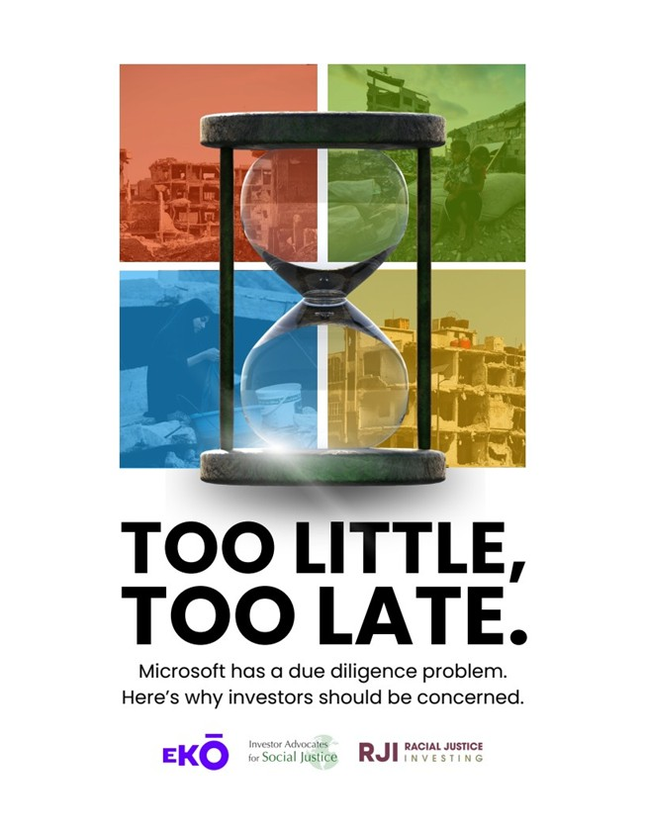
TOO LITTLE,TOO LATE.Microsoft has a due diligence problem.Here's why investors should be concerned.

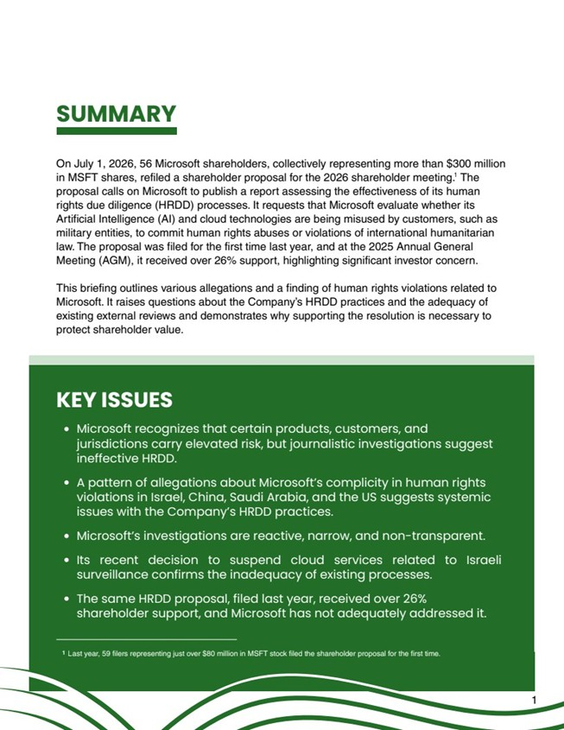
11Microsoft recognizes that certain products, customers, andjurisdictions carry elevated risk, but journalistic investigations suggestineffective HRDD.A pattern of allegations about Microsoft's complicity in human rightsviolations in Israel, China, Saudi Arabia, and the US suggests systemicissues with the Company's HRDD practices.Microsoft's investigations are reactive, narrow, and non-transparent. Its recent decision to suspend cloud services related to Israelisurveillance confirms the inadequacy of existing processes.The same HRDD proposal, filed last year, received over 26%shareholder support, and Microsoft has not adequately addressed it. Last year, 59 filers representing just over $80 million in MSFT stock filed the shareholder proposal for the first time.1On July 1, 2026, 56 Microsoft shareholders, collectively representing more than $300 millionin MSFT shares, refiled a shareholder proposal for the 2026 shareholder meeting. Theproposal calls on Microsoft to publish a report assessing the effectiveness of its humanrights due diligence (HRDD) processes. It requests that Microsoft evaluate whether itsArtificial Intelligence (AI) and cloud technologies are being misused by customers, such asmilitary entities, to commit human rights abuses or violations of international humanitarianlaw. The proposal was filed for the first time last year, and at the 2025 Annual GeneralMeeting (AGM), it received over 26% support, highlighting significant investor concern.This briefing outlines various allegations and a finding of human rights violations related to Microsoft. It raises questions about the Company's HRDD practices and the adequacy ofexisting external reviews and demonstrates why supporting the resolution is necessary toprotect shareholder value. SUMMARYKEY ISSUES11

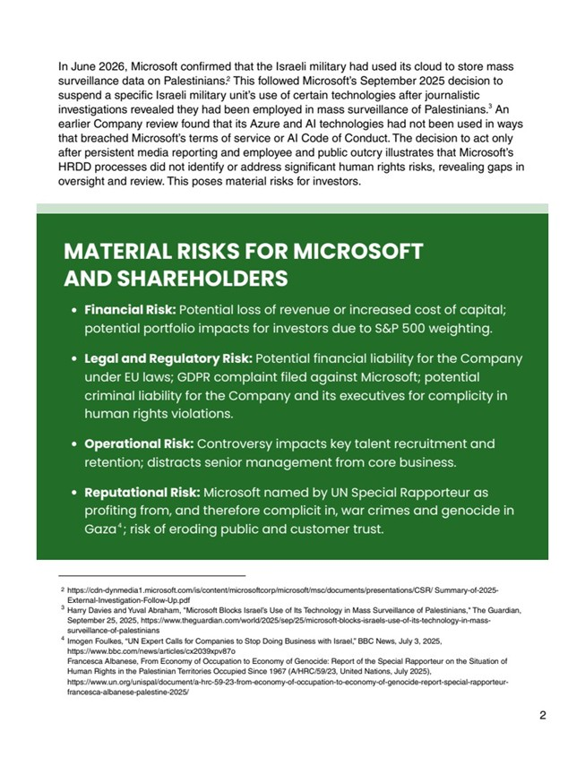
Financial Risk: Potential loss of revenue or increased cost of capital;potential portfolio impacts for investors due to S&P 500 weighting.Legal and Regulatory Risk: Potential financial liability for the Companyunder EU laws; GDPR complaint filed against Microsoft; potentialcriminal liability for the Company and its executives for complicity inhuman rights violations.Operational Risk: Controversy impacts key talent recruitment andretention; distracts senior management from core business.Reputational Risk: Microsoft named by UN Special Rapporteur asprofiting from, and therefore complicit in, war crimes and genocide inGaza ; risk of eroding public and customer trust. 2In June 2026, Microsoft confirmed that the Israeli military had used its cloud to store masssurveillance data on Palestinians. This followed Microsoft's September 2025 decision tosuspend a specific Israeli military unit's use of certain technologies after journalisticinvestigations revealed they had been employed in mass surveillance of Palestinians. Anearlier Company review found that its Azure and AI technologies had not been used in waysthat breached Microsoft's terms of service or AI Code of Conduct. The decision to act onlyafter persistent media reporting and employee and public outcry illustrates that Microsoft'sHRDD processes did not identify or address significant human rights risks, revealing gaps inoversight and review. This poses material risks for investors.MATERIAL RISKS FOR MICROSOFTAND SHAREHOLDERShttps://cdn-dynmedia1.microsoft.com/is/content/microsoftcorp/microsoft/msc/documents/presentations/CSR/ Summary-of-2025-External-Investigation-Follow-Up.pdfHarry Davies and Yuval Abraham, "Microsoft Blocks Israel's Use of Its Technology in Mass Surveillance of Palestinians," The Guardian,September 25, 2025, https://www.theguardian.com/world/2025/sep/25/microsoft-blocks-israels-use-of-its-technology-in-mass-surveillance-of-palestiniansImogen Foulkes, "UN Expert Calls for Companies to Stop Doing Business with Israel," BBC News, July 3, 2025,https://www.bbc.com/news/articles/cx2039xpv87o Francesca Albanese, From Economy of Occupation to Economy of Genocide: Report of the Special Rapporteur on the Situation ofHuman Rights in the Palestinian Territories Occupied Since 1967 (A/HRC/59/23, United Nations, July 2025),https://www.un.org/unispal/document/a-hrc-59-23-from-economy-of-occupation-to-economy-of-genocide-report-special-rapporteur-francesca-albanese-palestine-2025/ 234234

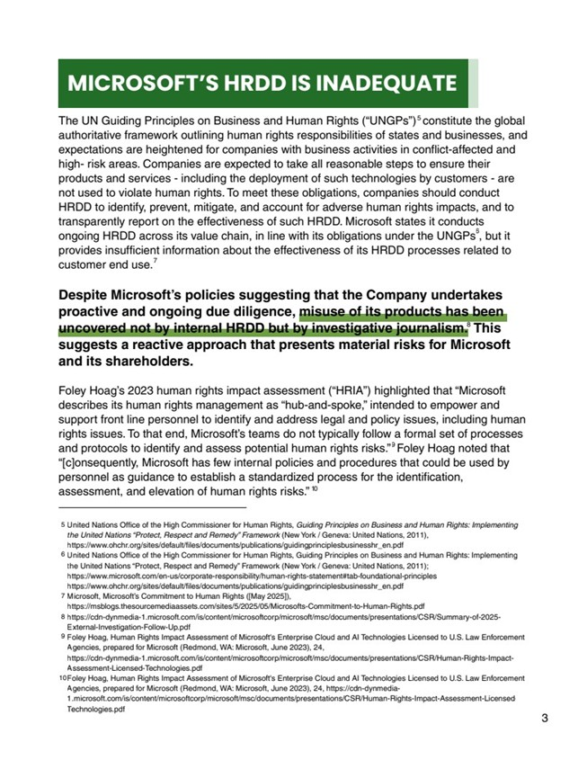
The UN Guiding Principles on Business and Human Rights ("UNGPs") constitute the globalauthoritative framework outlining human rights responsibilities of states and businesses, andexpectations are heightened for companies with business activities in conflict-affected andhigh- risk areas. Companies are expected to take all reasonable steps to ensure theirproducts and services - including the deployment of such technologies by customers - arenot used to violate human rights. To meet these obligations, companies should conductHRDD to identify, prevent, mitigate, and account for adverse human rights impacts, and totransparently report on the effectiveness of such HRDD. Microsoft states it conductsongoing HRDD across its value chain, in line with its obligations under the UNGPs , but itprovides insufficient information about the effectiveness of its HRDD processes related tocustomer end use. Despite Microsoft's policies suggesting that the Company undertakesproactive and ongoing due diligence, misuse of its products has beenuncovered not by internal HRDD but by investigative journalism. Thissuggests a reactive approach that presents material risks for Microsoftand its shareholders. Foley Hoag's 2023 human rights impact assessment ("HRIA") highlighted that "Microsoftdescribes its human rights management as "hub-and-spoke," intended to empower andsupport front line personnel to identify and address legal and policy issues, including humanrights issues. To that end, Microsoft's teams do not typically follow a formal set of processesand protocols to identify and assess potential human rights risks." Foley Hoag noted that"[c]onsequently, Microsoft has few internal policies and procedures that could be used bypersonnel as guidance to establish a standardized process for the identification,assessment, and elevation of human rights risks."MICROSOFT'S HRDD IS INADEQUATEUnited Nations Office of the High Commissioner for Human Rights, Guiding Principles on Business and Human Rights: Implementingthe United Nations "Protect, Respect and Remedy" Framework (New York / Geneva: United Nations, 2011),https://www.ohchr.org/sites/default/files/documents/publications/guidingprinciplesbusinesshr_en.pdfUnited Nations Office of the High Commissioner for Human Rights, Guiding Principles on Business and Human Rights: Implementingthe United Nations "Protect, Respect and Remedy" Framework (New York / Geneva: United Nations, 2011);https://www.microsoft.com/en-us/corporate-responsibility/human-rights-statement#tab-foundational-principleshttps://www.ohchr.org/sites/default/files/documents/publications/guidingprinciplesbusinesshr_en.pdfMicrosoft, Microsoft's Commitment to Human Rights ([May 2025]),https://msblogs.thesourcemediaassets.com/sites/5/2025/05/Microsofts-Commitment-to-Human-Rights.pdf https://cdn-dynmedia-1.microsoft.com/is/content/microsoftcorp/microsoft/msc/documents/presentations/CSR/Summary-of-2025-External-Investigation-Follow-Up.pdfFoley Hoag, Human Rights Impact Assessment of Microsoft's Enterprise Cloud and AI Technologies Licensed to U.S. Law EnforcementAgencies, prepared for Microsoft (Redmond, WA: Microsoft, June 2023), 24, https://cdn-dynmedia-1.microsoft.com/is/content/microsoftcorp/microsoft/msc/documents/presentations/CSR/Human-Rights-Impact-Assessment-Licensed-Technologies.pdf Foley Hoag, Human Rights Impact Assessment of Microsoft's Enterprise Cloud and AI Technologies Licensed to U.S. Law EnforcementAgencies, prepared for Microsoft (Redmond, WA: Microsoft, June 2023), 24, https://cdn-dynmedia-1.microsoft.com/is/content/microsoftcorp/microsoft/msc/documents/presentations/CSR/Human-Rights-Impact-Assessment-Licensed-Technologies.pdf 356789105678910

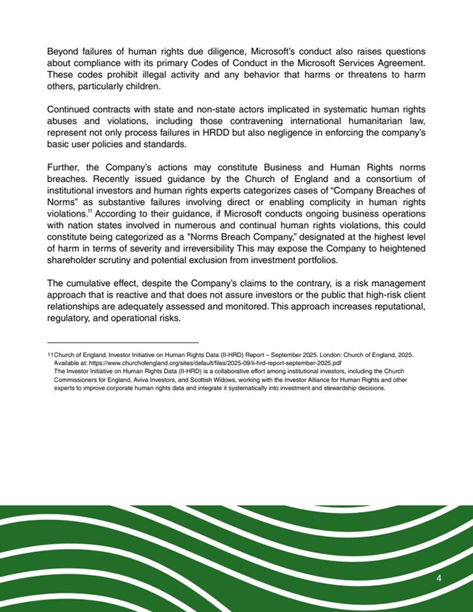
4Church of England. Investor Initiative on Human Rights Data (II-HRD) Report ? September 2025. London: Church of England, 2025.Available at: https://www.churchofengland.org/sites/default/files/2025-09/ii-hrd-report-september-2025.pdf The Investor Initiative on Human Rights Data (II-HRD) is a collaborative effort among institutional investors, including the ChurchCommissioners for England, Aviva Investors, and Scottish Widows, working with the Investor Alliance for Human Rights and otherexperts to improve corporate human rights data and integrate it systematically into investment and stewardship decisions.Beyond failures of human rights due diligence, Microsoft's conduct also raises questionsabout compliance with its primary Codes of Conduct in the Microsoft Services Agreement.These codes prohibit illegal activity and any behavior that harms or threatens to harmothers, particularly children. Continued contracts with state and non-state actors implicated in systematic human rightsabuses and violations, including those contravening international humanitarian law,represent not only process failures in HRDD but also negligence in enforcing the company'sbasic user policies and standards.Further, the Company's actions may constitute Business and Human Rights normsbreaches. Recently issued guidance by the Church of England and a consortium ofinstitutional investors and human rights experts categorizes cases of "Company Breaches ofNorms" as substantive failures involving direct or enabling complicity in human rightsviolations. According to their guidance, if Microsoft conducts ongoing business operationswith nation states involved in numerous and continual human rights violations, this couldconstitute being categorized as a "Norms Breach Company," designated at the highest levelof harm in terms of severity and irreversibility This may expose the Company to heightenedshareholder scrutiny and potential exclusion from investment portfolios.The cumulative effect, despite the Company's claims to the contrary, is a risk managementapproach that is reactive and that does not assure investors or the public that high-risk clientrelationships are adequately assessed and monitored. This approach increases reputational,regulatory, and operational risks. 1111

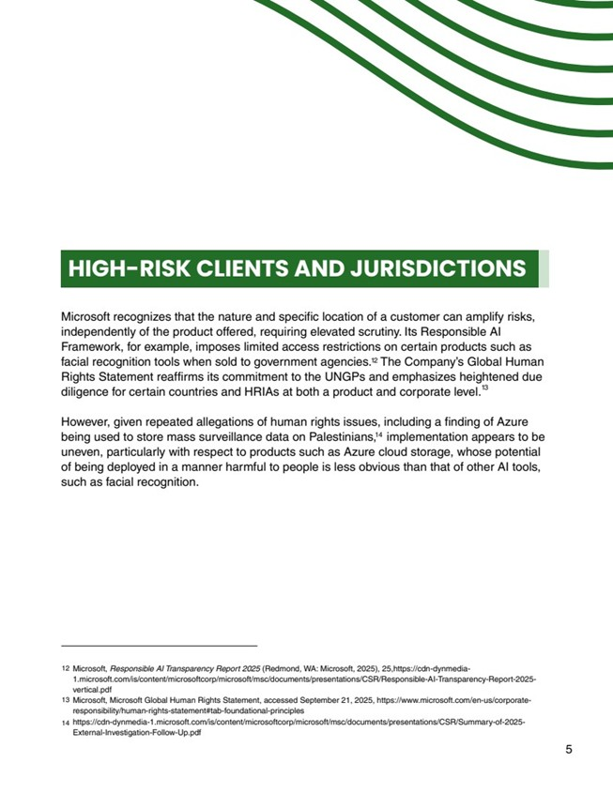
Microsoft recognizes that the nature and specific location of a customer can amplify risks,independently of the product offered, requiring elevated scrutiny. Its Responsible AIFramework, for example, imposes limited access restrictions on certain products such asfacial recognition tools when sold to government agencies. The Company's Global HumanRights Statement reaffirms its commitment to the UNGPs and emphasizes heightened duediligence for certain countries and HRIAs at both a product and corporate level. However, given repeated allegations of human rights issues, including a finding of Azurebeing used to store mass surveillance data on Palestinians, implementation appears to beuneven, particularly with respect to products such as Azure cloud storage, whose potentialof being deployed in a manner harmful to people is less obvious than that of other AI tools,such as facial recognition. HIGH-RISK CLIENTS AND JURISDICTIONS 121314Microsoft, Responsible AI Transparency Report 2025 (Redmond, WA: Microsoft, 2025), 25,https://cdn-dynmedia-1.microsoft.com/is/content/microsoftcorp/microsoft/msc/documents/presentations/CSR/Responsible-AI-Transparency-Report-2025-vertical.pdf Microsoft, Microsoft Global Human Rights Statement, accessed September 21, 2025, https://www.microsoft.com/en-us/corporate-responsibility/human-rights-statement#tab-foundational-principles https://cdn-dynmedia-1.microsoft.com/is/content/microsoftcorp/microsoft/msc/documents/presentations/CSR/Summary-of-2025-External-Investigation-Follow-Up.pdf5121314121314

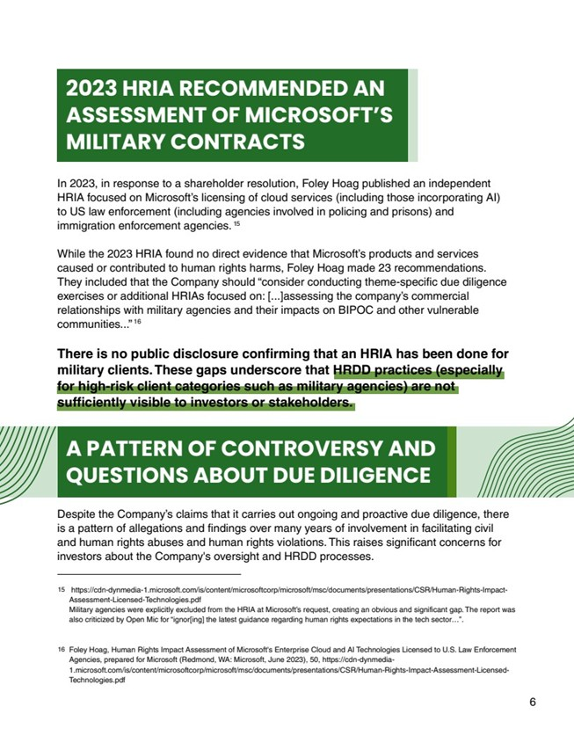
In 2023, in response to a shareholder resolution, Foley Hoag published an independentHRIA focused on Microsoft's licensing of cloud services (including those incorporating AI)to US law enforcement (including agencies involved in policing and prisons) andimmigration enforcement agencies. While the 2023 HRIA found no direct evidence that Microsoft's products and servicescaused or contributed to human rights harms, Foley Hoag made 23 recommendations.They included that the Company should "consider conducting theme-specific due diligenceexercises or additional HRIAs focused on: [...]assessing the company's commercialrelationships with military agencies and their impacts on BIPOC and other vulnerablecommunities..." There is no public disclosure confirming that an HRIA has been done formilitary clients. These gaps underscore that HRDD practices (especiallyfor high-risk client categories such as military agencies) are notsufficiently visible to investors or stakeholders.2023 HRIA RECOMMENDED ANASSESSMENT OF MICROSOFT'SMILITARY CONTRACTSA PATTERN OF CONTROVERSY ANDQUESTIONS ABOUT DUE DILIGENCEDespite the Company's claims that it carries out ongoing and proactive due diligence, thereis a pattern of allegations and findings over many years of involvement in facilitating civiland human rights abuses and human rights violations. This raises significant concerns forinvestors about the Company's oversight and HRDD processes. https://cdn-dynmedia-1.microsoft.com/is/content/microsoftcorp/microsoft/msc/documents/presentations/CSR/Human-Rights-Impact-Assessment-Licensed-Technologies.pdf Military agencies were explicitly excluded from the HRIA at Microsoft's request, creating an obvious and significant gap. The report wasalso criticized by Open Mic for "ignor[ing] the latest guidance regarding human rights expectations in the tech sector?".Foley Hoag, Human Rights Impact Assessment of Microsoft's Enterprise Cloud and AI Technologies Licensed to U.S. Law EnforcementAgencies, prepared for Microsoft (Redmond, WA: Microsoft, June 2023), 50, https://cdn-dynmedia-1.microsoft.com/is/content/microsoftcorp/microsoft/msc/documents/presentations/CSR/Human-Rights-Impact-Assessment-Licensed-Technologies.pdf 615161516

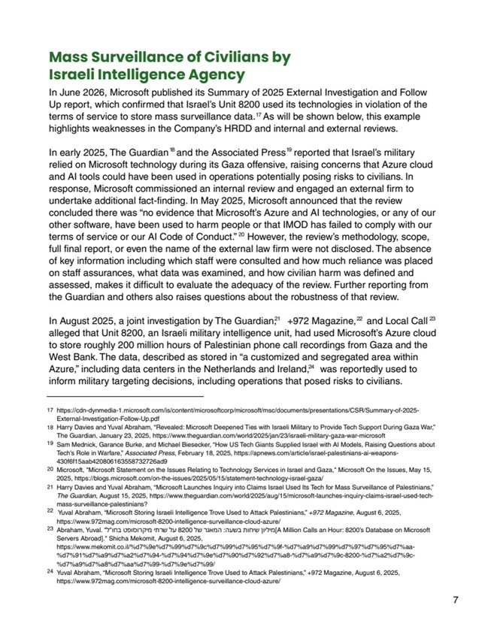
7Mass Surveillance of Civilians by Israeli Intelligence AgencyIn June 2026, Microsoft published its Summary of 2025 External Investigation and FollowUp report, which confirmed that Israel's Unit 8200 used its technologies in violation of theterms of service to store mass surveillance data. As will be shown below, this examplehighlights weaknesses in the Company's HRDD and internal and external reviews.In early 2025, The Guardian and the Associated Press reported that Israel's militaryrelied on Microsoft technology during its Gaza offensive, raising concerns that Azure cloudand AI tools could have been used in operations potentially posing risks to civilians. Inresponse, Microsoft commissioned an internal review and engaged an external firm toundertake additional fact-finding. In May 2025, Microsoft announced that the reviewconcluded there was "no evidence that Microsoft's Azure and AI technologies, or any of ourother software, have been used to harm people or that IMOD has failed to comply with ourterms of service or our AI Code of Conduct." However, the review's methodology, scope,full final report, or even the name of the external law firm were not disclosed. The absenceof key information including which staff were consulted and how much reliance was placedon staff assurances, what data was examined, and how civilian harm was defined andassessed, makes it difficult to evaluate the adequacy of the review. Further reporting fromthe Guardian and others also raises questions about the robustness of that review. In August 2025, a joint investigation by The Guardian, +972 Magazine, and Local Callalleged that Unit 8200, an Israeli military intelligence unit, had used Microsoft's Azure cloudto store roughly 200 million hours of Palestinian phone call recordings from Gaza and theWest Bank. The data, described as stored in "a customized and segregated area withinAzure," including data centers in the Netherlands and Ireland, was reportedly used toinform military targeting decisions, including operations that posed risks to civilians. https://cdn-dynmedia-1.microsoft.com/is/content/microsoftcorp/microsoft/msc/documents/presentations/CSR/Summary-of-2025-External-Investigation-Follow-Up.pdfHarry Davies and Yuval Abraham, "Revealed: Microsoft Deepened Ties with Israeli Military to Provide Tech Support During Gaza War,"The Guardian, January 23, 2025, https://www.theguardian.com/world/2025/jan/23/israeli-military-gaza-war-microsoftSam Mednick, Garance Burke, and Michael Biesecker, "How US Tech Giants Supplied Israel with AI Models, Raising Questions aboutTech's Role in Warfare," Associated Press, February 18, 2025, https://apnews.com/article/israel-palestinians-ai-weapons-430f6f15aab420806163558732726ad9Microsoft, "Microsoft Statement on the Issues Relating to Technology Services in Israel and Gaza," Microsoft On the Issues, May 15,2025, https://blogs.microsoft.com/on-the-issues/2025/05/15/statement-technology-israel-gaza/Harry Davies and Yuval Abraham, "Microsoft Launches Inquiry into Claims Israel Used Its Tech for Mass Surveillance of Palestinians,"The Guardian, August 15, 2025, https://www.theguardian.com/world/2025/aug/15/microsoft-launches-inquiry-claims-israel-used-tech-mass-surveillance-palestinians? Yuval Abraham, "Microsoft Storing Israeli Intelligence Trove Used to Attack Palestinians," +972 Magazine, August 6, 2025,https://www.972mag.com/microsoft-8200-intelligence-surveillance-cloud-azure/Abraham, Yuval. "?"??? ????????? ???? ?? 8200 ?? ????? :???? ????? ??????[A Million Calls an Hour: 8200's Database on MicrosoftServers Abroad]." Shicha Mekomit, August 6, 2025, https://www.mekomit.co.il/%d7%9e%d7%99%d7%9c%d7%99%d7%95%d7%9f-%d7%a9%d7%99%d7%97%d7%95%d7%aa-%d7%91%d7%a9%d7%a2%d7%94-%d7%94%d7%9e%d7%90%d7%92%d7%a8-%d7%a9%d7%9c-8200-%d7%a2%d7%9c-%d7%a9%d7%a8%d7%aa%d7%99-%d7%9e%d7%99/ Yuval Abraham, "Microsoft Storing Israeli Intelligence Trove Used to Attack Palestinians," +972 Magazine, August 6, 2025,https://www.972mag.com/microsoft-8200-intelligence-surveillance-cloud-azure/17181920212223241718192021222324

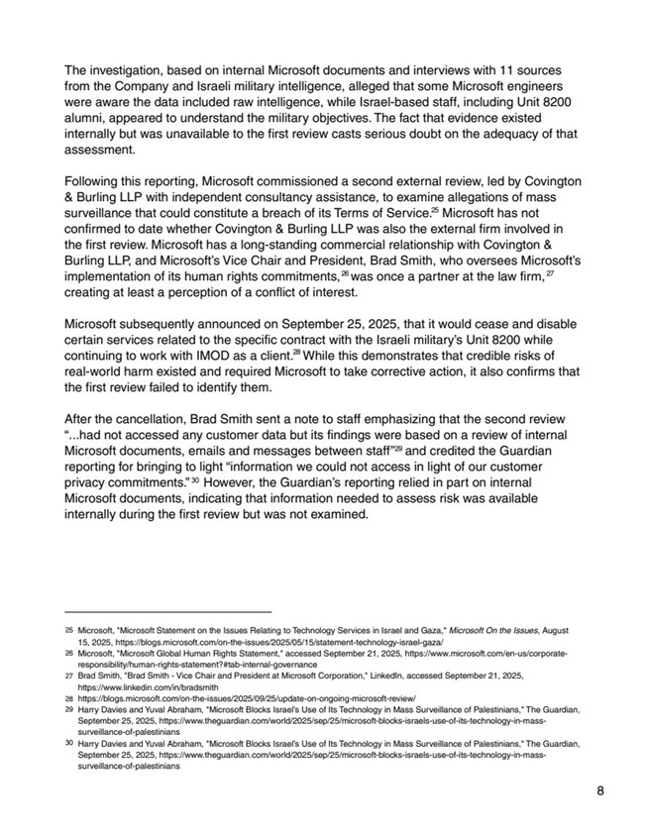
The investigation, based on internal Microsoft documents and interviews with 11 sourcesfrom the Company and Israeli military intelligence, alleged that some Microsoft engineerswere aware the data included raw intelligence, while Israel-based staff, including Unit 8200alumni, appeared to understand the military objectives. The fact that evidence existedinternally but was unavailable to the first review casts serious doubt on the adequacy of thatassessment.Following this reporting, Microsoft commissioned a second external review, led by Covington& Burling LLP with independent consultancy assistance, to examine allegations of masssurveillance that could constitute a breach of its Terms of Service. Microsoft has notconfirmed to date whether Covington & Burling LLP was also the external firm involved inthe first review. Microsoft has a long-standing commercial relationship with Covington &Burling LLP, and Microsoft's Vice Chair and President, Brad Smith, who oversees Microsoft'simplementation of its human rights commitments, was once a partner at the law firm,creating at least a perception of a conflict of interest.Microsoft subsequently announced on September 25, 2025, that it would cease and disablecertain services related to the specific contract with the Israeli military's Unit 8200 whilecontinuing to work with IMOD as a client. While this demonstrates that credible risks ofreal-world harm existed and required Microsoft to take corrective action, it also confirms thatthe first review failed to identify them. After the cancellation, Brad Smith sent a note to staff emphasizing that the second review"...had not accessed any customer data but its findings were based on a review of internalMicrosoft documents, emails and messages between staff" and credited the Guardianreporting for bringing to light "information we could not access in light of our customerprivacy commitments." However, the Guardian's reporting relied in part on internalMicrosoft documents, indicating that information needed to assess risk was availableinternally during the first review but was not examined. Microsoft, "Microsoft Statement on the Issues Relating to Technology Services in Israel and Gaza," Microsoft On the Issues, August15, 2025, https://blogs.microsoft.com/on-the-issues/2025/05/15/statement-technology-israel-gaza/Microsoft, "Microsoft Global Human Rights Statement," accessed September 21, 2025, https://www.microsoft.com/en-us/corporate-responsibility/human-rights-statement?#tab-internal-governance Brad Smith, "Brad Smith - Vice Chair and President at Microsoft Corporation," LinkedIn, accessed September 21, 2025,https://www.linkedin.com/in/bradsmith https://blogs.microsoft.com/on-the-issues/2025/09/25/update-on-ongoing-microsoft-review/ Harry Davies and Yuval Abraham, "Microsoft Blocks Israel's Use of Its Technology in Mass Surveillance of Palestinians," The Guardian,September 25, 2025, https://www.theguardian.com/world/2025/sep/25/microsoft-blocks-israels-use-of-its-technology-in-mass-surveillance-of-palestiniansHarry Davies and Yuval Abraham, "Microsoft Blocks Israel's Use of Its Technology in Mass Surveillance of Palestinians," The Guardian,September 25, 2025, https://www.theguardian.com/world/2025/sep/25/microsoft-blocks-israels-use-of-its-technology-in-mass-surveillance-of-palestinians8252627282930252627282930

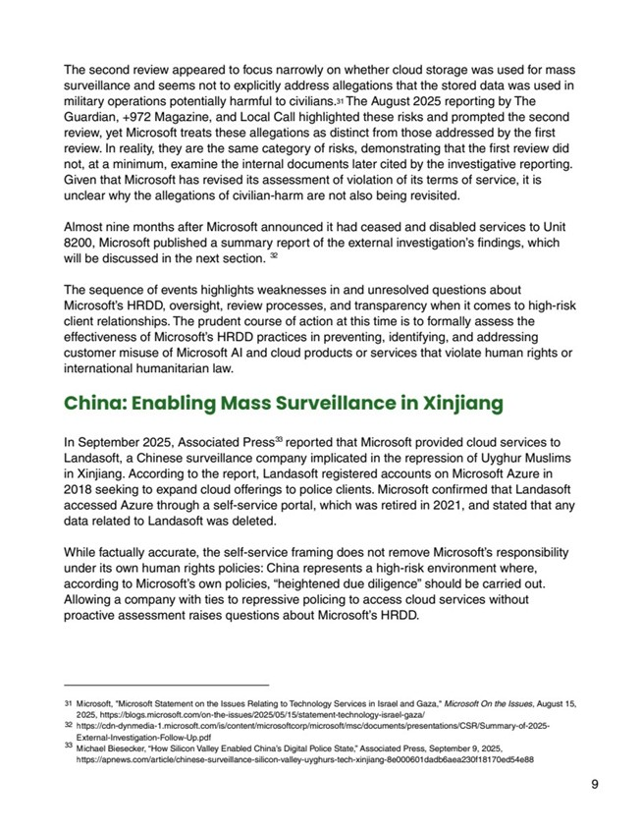
The second review appeared to focus narrowly on whether cloud storage was used for masssurveillance and seems not to explicitly address allegations that the stored data was used inmilitary operations potentially harmful to civilians. The August 2025 reporting by TheGuardian, +972 Magazine, and Local Call highlighted these risks and prompted the secondreview, yet Microsoft treats these allegations as distinct from those addressed by the firstreview. In reality, they are the same category of risks, demonstrating that the first review didnot, at a minimum, examine the internal documents later cited by the investigative reporting.Given that Microsoft has revised its assessment of violation of its terms of service, it isunclear why the allegations of civilian-harm are not also being revisited.Almost nine months after Microsoft announced it had ceased and disabled services to Unit8200, Microsoft published a summary report of the external investigation's findings, whichwill be discussed in the next section.The sequence of events highlights weaknesses in and unresolved questions aboutMicrosoft's HRDD, oversight, review processes, and transparency when it comes to high-riskclient relationships. The prudent course of action at this time is to formally assess theeffectiveness of Microsoft's HRDD practices in preventing, identifying, and addressingcustomer misuse of Microsoft AI and cloud products or services that violate human rights orinternational humanitarian law.Microsoft, "Microsoft Statement on the Issues Relating to Technology Services in Israel and Gaza," Microsoft On the Issues, August 15,2025, https://blogs.microsoft.com/on-the-issues/2025/05/15/statement-technology-israel-gaza/https://cdn-dynmedia-1.microsoft.com/is/content/microsoftcorp/microsoft/msc/documents/presentations/CSR/Summary-of-2025-External-Investigation-Follow-Up.pdf Michael Biesecker, "How Silicon Valley Enabled China's Digital Police State," Associated Press, September 9, 2025,https://apnews.com/article/chinese-surveillance-silicon-valley-uyghurs-tech-xinjiang-8e000601dadb6aea230f18170ed54e88 China: Enabling Mass Surveillance in XinjiangIn September 2025, Associated Press reported that Microsoft provided cloud services toLandasoft, a Chinese surveillance company implicated in the repression of Uyghur Muslimsin Xinjiang. According to the report, Landasoft registered accounts on Microsoft Azure in2018 seeking to expand cloud offerings to police clients. Microsoft confirmed that Landasoftaccessed Azure through a self-service portal, which was retired in 2021, and stated that anydata related to Landasoft was deleted. While factually accurate, the self-service framing does not remove Microsoft's responsibilityunder its own human rights policies: China represents a high-risk environment where,according to Microsoft's own policies, "heightened due diligence" should be carried out.Allowing a company with ties to repressive policing to access cloud services withoutproactive assessment raises questions about Microsoft's HRDD.9313233313233

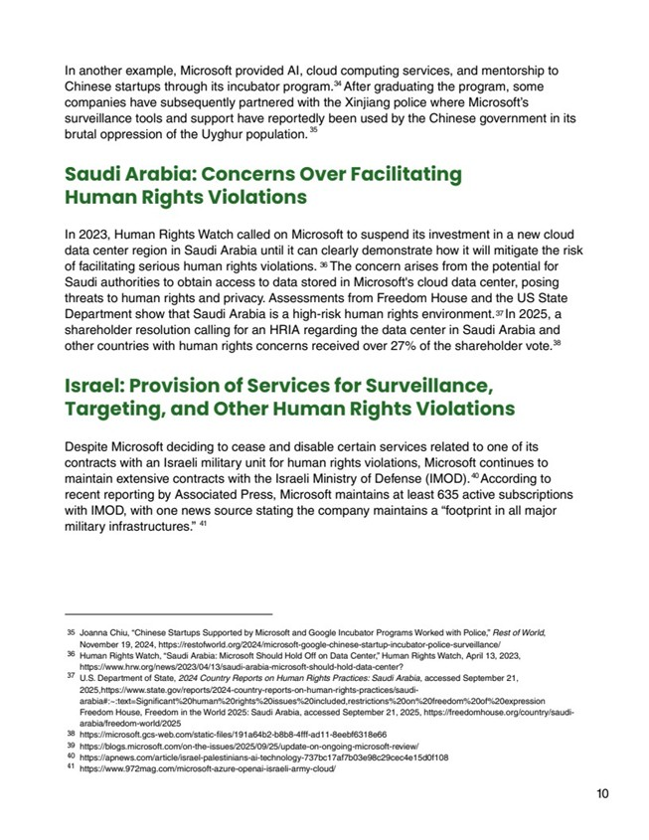
In another example, Microsoft provided AI, cloud computing services, and mentorship toChinese startups through its incubator program. After graduating the program, somecompanies have subsequently partnered with the Xinjiang police where Microsoft'ssurveillance tools and support have reportedly been used by the Chinese government in itsbrutal oppression of the Uyghur population.Saudi Arabia: Concerns Over Facilitating Human Rights ViolationsIn 2023, Human Rights Watch called on Microsoft to suspend its investment in a new clouddata center region in Saudi Arabia until it can clearly demonstrate how it will mitigate the riskof facilitating serious human rights violations. The concern arises from the potential forSaudi authorities to obtain access to data stored in Microsoft's cloud data center, posingthreats to human rights and privacy. Assessments from Freedom House and the US StateDepartment show that Saudi Arabia is a high-risk human rights environment. In 2025, ashareholder resolution calling for an HRIA regarding the data center in Saudi Arabia andother countries with human rights concerns received over 27% of the shareholder vote.Israel: Provision of Services for Surveillance, Targeting, and Other Human Rights ViolationsDespite Microsoft deciding to cease and disable certain services related to one of itscontracts with an Israeli military unit for human rights violations, Microsoft continues tomaintain extensive contracts with the Israeli Ministry of Defense (IMOD). According torecent reporting by Associated Press, Microsoft maintains at least 635 active subscriptionswith IMOD, with one news source stating the company maintains a "footprint in all majormilitary infrastructures."Joanna Chiu, "Chinese Startups Supported by Microsoft and Google Incubator Programs Worked with Police," Rest of World,November 19, 2024, https://restofworld.org/2024/microsoft-google-chinese-startup-incubator-police-surveillance/ Human Rights Watch, "Saudi Arabia: Microsoft Should Hold Off on Data Center," Human Rights Watch, April 13, 2023,https://www.hrw.org/news/2023/04/13/saudi-arabia-microsoft-should-hold-data-center?U.S. Department of State, 2024 Country Reports on Human Rights Practices: Saudi Arabia, accessed September 21,2025,https://www.state.gov/reports/2024-country-reports-on-human-rights-practices/saudi-arabia#:~:text=Significant%20human%20rights%20issues%20included,restrictions%20on%20freedom%20of%20expressionFreedom House, Freedom in the World 2025: Saudi Arabia, accessed September 21, 2025, https://freedomhouse.org/country/saudi-arabia/freedom-world/2025https://microsoft.gcs-web.com/static-files/191a64b2-b8b8-4fff-ad11-8eebf6318e66 https://blogs.microsoft.com/on-the-issues/2025/09/25/update-on-ongoing-microsoft-review/https://apnews.com/article/israel-palestinians-ai-technology-737bc17af7b03e98c29cec4e15d0f108 https://www.972mag.com/microsoft-azure-openai-israeli-army-cloud/ 103435363738404135363738394041

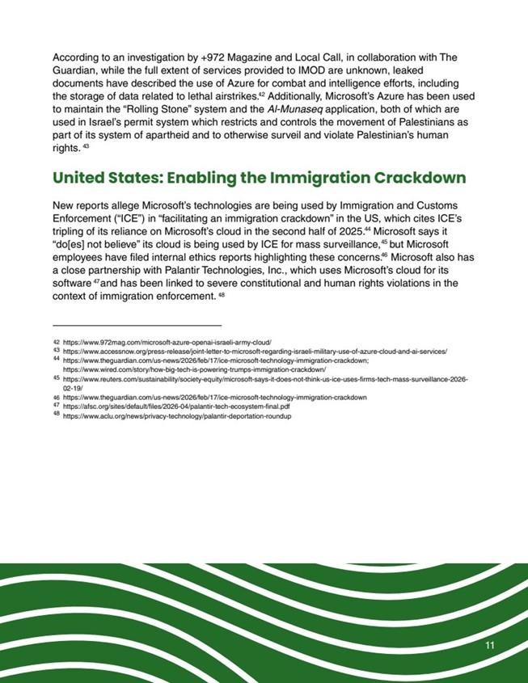
11https://www.972mag.com/microsoft-azure-openai-israeli-army-cloud/ https://www.accessnow.org/press-release/joint-letter-to-microsoft-regarding-israeli-military-use-of-azure-cloud-and-ai-services/ https://www.theguardian.com/us-news/2026/feb/17/ice-microsoft-technology-immigration-crackdown; https://www.wired.com/story/how-big-tech-is-powering-trumps-immigration-crackdown/ https://www.reuters.com/sustainability/society-equity/microsoft-says-it-does-not-think-us-ice-uses-firms-tech-mass-surveillance-2026-02-19/ https://www.theguardian.com/us-news/2026/feb/17/ice-microsoft-technology-immigration-crackdown https://afsc.org/sites/default/files/2026-04/palantir-tech-ecosystem-final.pdf https://www.aclu.org/news/privacy-technology/palantir-deportation-roundup United States: Enabling the Immigration CrackdownNew reports allege Microsoft's technologies are being used by Immigration and CustomsEnforcement ("ICE") in "facilitating an immigration crackdown" in the US, which cites ICE'stripling of its reliance on Microsoft's cloud in the second half of 2025. Microsoft says it"do[es] not believe" its cloud is being used by ICE for mass surveillance, but Microsoftemployees have filed internal ethics reports highlighting these concerns. Microsoft also hasa close partnership with Palantir Technologies, Inc., which uses Microsoft's cloud for itssoftware and has been linked to severe constitutional and human rights violations in thecontext of immigration enforcement.According to an investigation by +972 Magazine and Local Call, in collaboration with TheGuardian, while the full extent of services provided to IMOD are unknown, leakeddocuments have described the use of Azure for combat and intelligence efforts, includingthe storage of data related to lethal airstrikes. Additionally, Microsoft's Azure has been usedto maintain the "Rolling Stone" system and the Al-Munaseq application, both of which areused in Israel's permit system which restricts and controls the movement of Palestinians aspart of its system of apartheid and to otherwise surveil and violate Palestinian's humanrights.4243444546474842434445464748

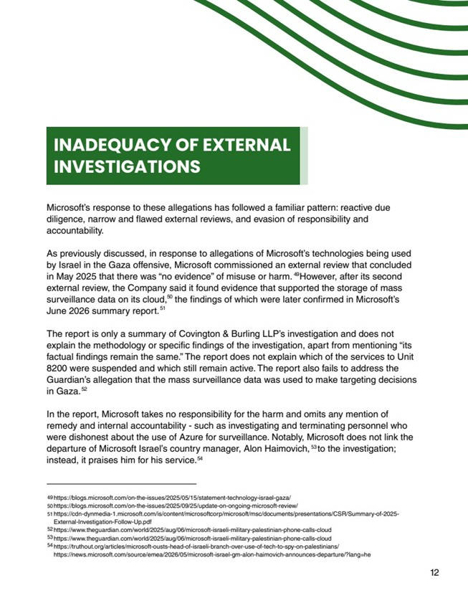
INADEQUACY OF EXTERNALINVESTIGATIONSMicrosoft's response to these allegations has followed a familiar pattern: reactive duediligence, narrow and flawed external reviews, and evasion of responsibility andaccountability. As previously discussed, in response to allegations of Microsoft's technologies being usedby Israel in the Gaza offensive, Microsoft commissioned an external review that concludedin May 2025 that there was "no evidence" of misuse or harm. However, after its secondexternal review, the Company said it found evidence that supported the storage of masssurveillance data on its cloud, the findings of which were later confirmed in Microsoft'sJune 2026 summary report. The report is only a summary of Covington & Burling LLP's investigation and does notexplain the methodology or specific findings of the investigation, apart from mentioning "itsfactual findings remain the same." The report does not explain which of the services to Unit8200 were suspended and which still remain active. The report also fails to address theGuardian's allegation that the mass surveillance data was used to make targeting decisionsin Gaza.In the report, Microsoft takes no responsibility for the harm and omits any mention ofremedy and internal accountability - such as investigating and terminating personnel whowere dishonest about the use of Azure for surveillance. Notably, Microsoft does not link thedeparture of Microsoft Israel's country manager, Alon Haimovich, to the investigation;instead, it praises him for his service. https://blogs.microsoft.com/on-the-issues/2025/05/15/statement-technology-israel-gaza/ https://blogs.microsoft.com/on-the-issues/2025/09/25/update-on-ongoing-microsoft-review/ https://cdn-dynmedia-1.microsoft.com/is/content/microsoftcorp/microsoft/msc/documents/presentations/CSR/Summary-of-2025-External-Investigation-Follow-Up.pdfhttps://www.theguardian.com/world/2025/aug/06/microsoft-israeli-military-palestinian-phone-calls-cloud https://www.theguardian.com/world/2025/aug/06/microsoft-israeli-military-palestinian-phone-calls-cloudhttps://truthout.org/articles/microsoft-ousts-head-of-israeli-branch-over-use-of-tech-to-spy-on-palestinians/ https://news.microsoft.com/source/emea/2026/05/microsoft-israel-gm-alon-haimovich-announces-departure/?lang=he 12495051525354495051525354

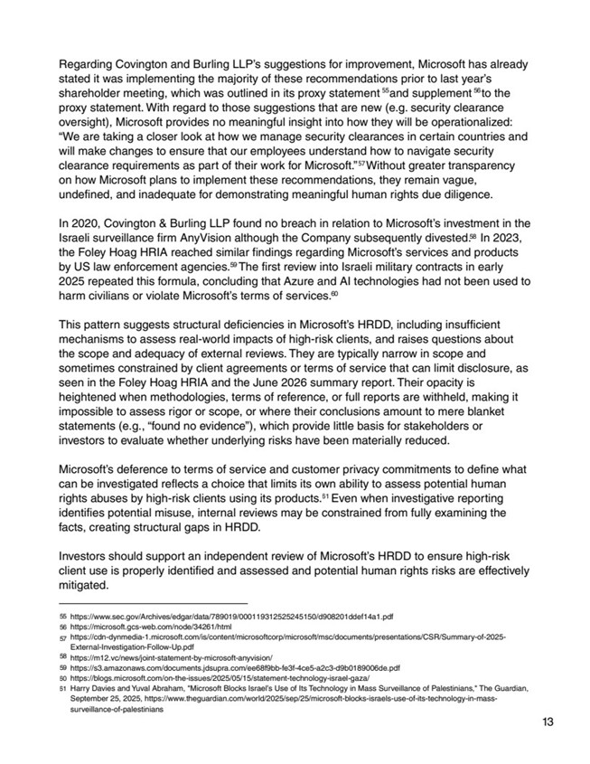
Regarding Covington and Burling LLP's suggestions for improvement, Microsoft has alreadystated it was implementing the majority of these recommendations prior to last year'sshareholder meeting, which was outlined in its proxy statement and supplement to theproxy statement. With regard to those suggestions that are new (e.g. security clearanceoversight), Microsoft provides no meaningful insight into how they will be operationalized:"We are taking a closer look at how we manage security clearances in certain countries andwill make changes to ensure that our employees understand how to navigate securityclearance requirements as part of their work for Microsoft." Without greater transparencyon how Microsoft plans to implement these recommendations, they remain vague,undefined, and inadequate for demonstrating meaningful human rights due diligence. In 2020, Covington & Burling LLP found no breach in relation to Microsoft's investment in theIsraeli surveillance firm AnyVision although the Company subsequently divested. In 2023,the Foley Hoag HRIA reached similar findings regarding Microsoft's services and productsby US law enforcement agencies. The first review into Israeli military contracts in early2025 repeated this formula, concluding that Azure and AI technologies had not been used toharm civilians or violate Microsoft's terms of services. This pattern suggests structural deficiencies in Microsoft's HRDD, including insufficientmechanisms to assess real-world impacts of high-risk clients, and raises questions aboutthe scope and adequacy of external reviews. They are typically narrow in scope andsometimes constrained by client agreements or terms of service that can limit disclosure, asseen in the Foley Hoag HRIA and the June 2026 summary report. Their opacity isheightened when methodologies, terms of reference, or full reports are withheld, making itimpossible to assess rigor or scope, or where their conclusions amount to mere blanketstatements (e.g., "found no evidence"), which provide little basis for stakeholders orinvestors to evaluate whether underlying risks have been materially reduced.Microsoft's deference to terms of service and customer privacy commitments to define whatcan be investigated reflects a choice that limits its own ability to assess potential humanrights abuses by high-risk clients using its products. Even when investigative reportingidentifies potential misuse, internal reviews may be constrained from fully examining thefacts, creating structural gaps in HRDD.Investors should support an independent review of Microsoft's HRDD to ensure high-riskclient use is properly identified and assessed and potential human rights risks are effectivelymitigated.https://www.sec.gov/Archives/edgar/data/789019/000119312525245150/d908201ddef14a1.pdf https://microsoft.gcs-web.com/node/34261/html https://cdn-dynmedia-1.microsoft.com/is/content/microsoftcorp/microsoft/msc/documents/presentations/CSR/Summary-of-2025-External-Investigation-Follow-Up.pdf https://m12.vc/news/joint-statement-by-microsoft-anyvision/https://s3.amazonaws.com/documents.jdsupra.com/ee68f9bb-fe3f-4ce5-a2c3-d9b0189006de.pdf https://blogs.microsoft.com/on-the-issues/2025/05/15/statement-technology-israel-gaza/ Harry Davies and Yuval Abraham, "Microsoft Blocks Israel's Use of Its Technology in Mass Surveillance of Palestinians," The Guardian,September 25, 2025, https://www.theguardian.com/world/2025/sep/25/microsoft-blocks-israels-use-of-its-technology-in-mass-surveillance-of-palestinians135556575859606155565758596061

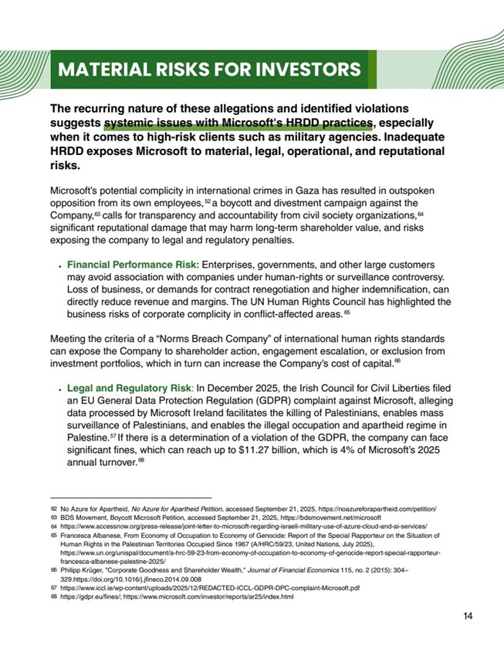
MATERIAL RISKS FOR INVESTORSThe recurring nature of these allegations and identified violationssuggests systemic issues with Microsoft's HRDD practices, especiallywhen it comes to high-risk clients such as military agencies. InadequateHRDD exposes Microsoft to material, legal, operational, and reputationalrisks.Microsoft's potential complicity in international crimes in Gaza has resulted in outspokenopposition from its own employees, a boycott and divestment campaign against theCompany, calls for transparency and accountability from civil society organizations,significant reputational damage that may harm long-term shareholder value, and risksexposing the company to legal and regulatory penalties.Financial Performance Risk: Enterprises, governments, and other large customersmay avoid association with companies under human-rights or surveillance controversy.Loss of business, or demands for contract renegotiation and higher indemnification, candirectly reduce revenue and margins. The UN Human Rights Council has highlighted thebusiness risks of corporate complicity in conflict-affected areas. Meeting the criteria of a "Norms Breach Company" of international human rights standardscan expose the Company to shareholder action, engagement escalation, or exclusion frominvestment portfolios, which in turn can increase the Company's cost of capital. Legal and Regulatory Risk: In December 2025, the Irish Council for Civil Liberties filedan EU General Data Protection Regulation (GDPR) complaint against Microsoft, allegingdata processed by Microsoft Ireland facilitates the killing of Palestinians, enables masssurveillance of Palestinians, and enables the illegal occupation and apartheid regime inPalestine. If there is a determination of a violation of the GDPR, the company can facesignificant fines, which can reach up to $11.27 billion, which is 4% of Microsoft's 2025annual turnover.No Azure for Apartheid, No Azure for Apartheid Petition, accessed September 21, 2025, https://noazureforapartheid.com/petition/ BDS Movement, Boycott Microsoft Petition, accessed September 21, 2025, https://bdsmovement.net/microsofthttps://www.accessnow.org/press-release/joint-letter-to-microsoft-regarding-israeli-military-use-of-azure-cloud-and-ai-services/ Francesca Albanese, From Economy of Occupation to Economy of Genocide: Report of the Special Rapporteur on the Situation ofHuman Rights in the Palestinian Territories Occupied Since 1967 (A/HRC/59/23, United Nations, July 2025),https://www.un.org/unispal/document/a-hrc-59-23-from-economy-of-occupation-to-economy-of-genocide-report-special-rapporteur-francesca-albanese-palestine-2025/ Philipp Krüger, "Corporate Goodness and Shareholder Wealth," Journal of Financial Economics 115, no. 2 (2015): 304?329.https://doi.org/10.1016/j.jfineco.2014.09.008 https://www.iccl.ie/wp-content/uploads/2025/12/REDACTED-ICCL-GDPR-DPC-complaint-Microsoft.pdfhttps://gdpr.eu/fines/; https://www.microsoft.com/investor/reports/ar25/index.html 146263646566676862636465666768

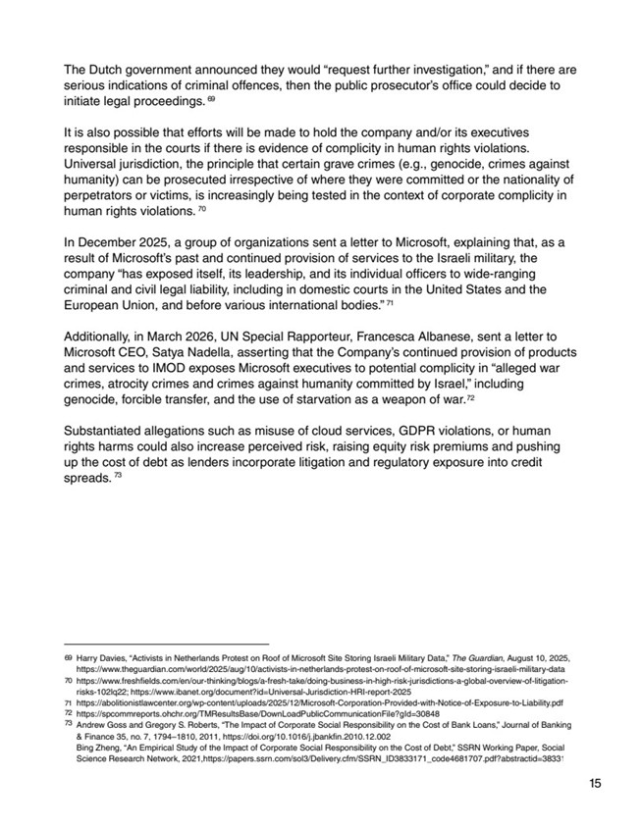
The Dutch government announced they would "request further investigation," and if there areserious indications of criminal offences, then the public prosecutor's office could decide toinitiate legal proceedings.It is also possible that efforts will be made to hold the company and/or its executivesresponsible in the courts if there is evidence of complicity in human rights violations.Universal jurisdiction, the principle that certain grave crimes (e.g., genocide, crimes againsthumanity) can be prosecuted irrespective of where they were committed or the nationality ofperpetrators or victims, is increasingly being tested in the context of corporate complicity inhuman rights violations. In December 2025, a group of organizations sent a letter to Microsoft, explaining that, as aresult of Microsoft's past and continued provision of services to the Israeli military, thecompany "has exposed itself, its leadership, and its individual officers to wide-rangingcriminal and civil legal liability, including in domestic courts in the United States and theEuropean Union, and before various international bodies." Additionally, in March 2026, UN Special Rapporteur, Francesca Albanese, sent a letter toMicrosoft CEO, Satya Nadella, asserting that the Company's continued provision of productsand services to IMOD exposes Microsoft executives to potential complicity in "alleged warcrimes, atrocity crimes and crimes against humanity committed by Israel," includinggenocide, forcible transfer, and the use of starvation as a weapon of war.Substantiated allegations such as misuse of cloud services, GDPR violations, or humanrights harms could also increase perceived risk, raising equity risk premiums and pushingup the cost of debt as lenders incorporate litigation and regulatory exposure into creditspreads.Harry Davies, "Activists in Netherlands Protest on Roof of Microsoft Site Storing Israeli Military Data," The Guardian, August 10, 2025, https://www.theguardian.com/world/2025/aug/10/activists-in-netherlands-protest-on-roof-of-microsoft-site-storing-israeli-military-data https://www.freshfields.com/en/our-thinking/blogs/a-fresh-take/doing-business-in-high-risk-jurisdictions-a-global-overview-of-litigation-risks-102lq22; https://www.ibanet.org/document?id=Universal-Jurisdiction-HRI-report-2025 https://abolitionistlawcenter.org/wp-content/uploads/2025/12/Microsoft-Corporation-Provided-with-Notice-of-Exposure-to-Liability.pdf https://spcommreports.ohchr.org/TMResultsBase/DownLoadPublicCommunicationFile?gId=30848 Andrew Goss and Gregory S. Roberts, "The Impact of Corporate Social Responsibility on the Cost of Bank Loans," Journal of Banking& Finance 35, no. 7, 1794?1810, 2011, https://doi.org/10.1016/j.jbankfin.2010.12.002Bing Zheng, "An Empirical Study of the Impact of Corporate Social Responsibility on the Cost of Debt," SSRN Working Paper, SocialScience Research Network, 2021,https://papers.ssrn.com/sol3/Delivery.cfm/SSRN_ID3833171_code4681707.pdf?abstractid=3833171 1569707172736970717273

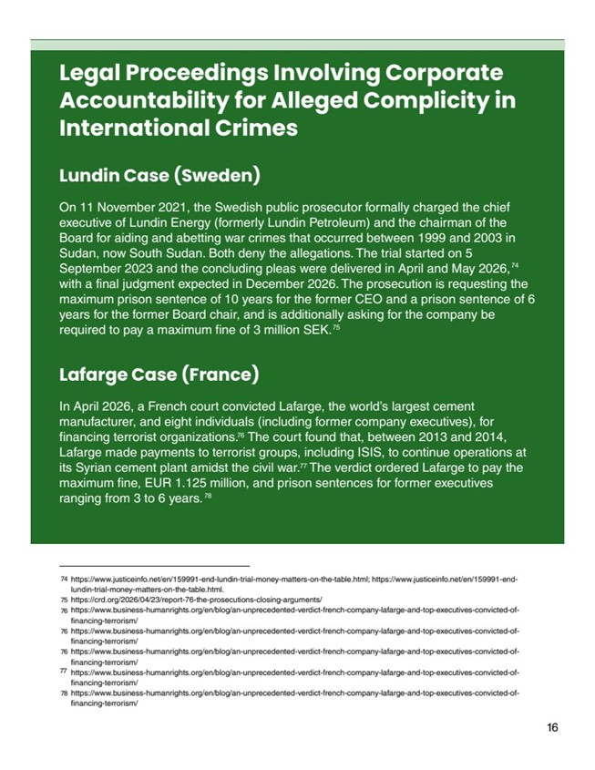
Legal Proceedings Involving CorporateAccountability for Alleged Complicity inInternational CrimesLundin Case (Sweden)On 11 November 2021, the Swedish public prosecutor formally charged the chiefexecutive of Lundin Energy (formerly Lundin Petroleum) and the chairman of theBoard for aiding and abetting war crimes that occurred between 1999 and 2003 inSudan, now South Sudan. Both deny the allegations. The trial started on 5September 2023 and the concluding pleas were delivered in April and May 2026,with a final judgment expected in December 2026. The prosecution is requesting themaximum prison sentence of 10 years for the former CEO and a prison sentence of 6years for the former Board chair, and is additionally asking for the company berequired to pay a maximum fine of 3 million SEK.In April 2026, a French court convicted Lafarge, the world's largest cementmanufacturer, and eight individuals (including former company executives), forfinancing terrorist organizations. The court found that, between 2013 and 2014,Lafarge made payments to terrorist groups, including ISIS, to continue operations atits Syrian cement plant amidst the civil war. The verdict ordered Lafarge to pay themaximum fine, EUR 1.125 million, and prison sentences for former executivesranging from 3 to 6 years. Lafarge Case (France)167475767778https://www.justiceinfo.net/en/159991-end-lundin-trial-money-matters-on-the-table.html; https://www.justiceinfo.net/en/159991-end-lundin-trial-money-matters-on-the-table.html. https://crd.org/2026/04/23/report-76-the-prosecutions-closing-arguments/https://www.business-humanrights.org/en/blog/an-unprecedented-verdict-french-company-lafarge-and-top-executives-convicted-of-financing-terrorism/ https://www.business-humanrights.org/en/blog/an-unprecedented-verdict-french-company-lafarge-and-top-executives-convicted-of-financing-terrorism/ https://www.business-humanrights.org/en/blog/an-unprecedented-verdict-french-company-lafarge-and-top-executives-convicted-of-financing-terrorism/ https://www.business-humanrights.org/en/blog/an-unprecedented-verdict-french-company-lafarge-and-top-executives-convicted-of-financing-terrorism/ https://www.business-humanrights.org/en/blog/an-unprecedented-verdict-french-company-lafarge-and-top-executives-convicted-of-financing-terrorism/ 74757676767778

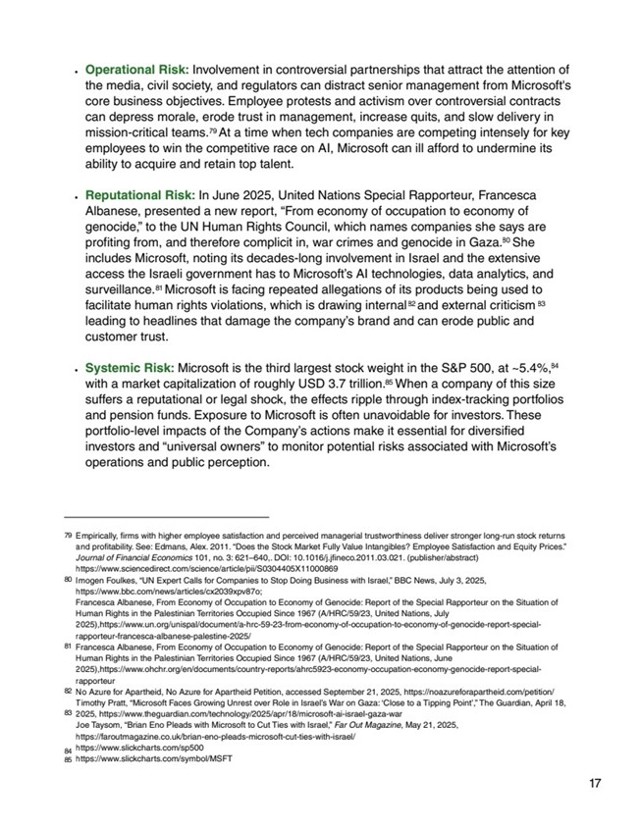
Operational Risk: Involvement in controversial partnerships that attract the attention ofthe media, civil society, and regulators can distract senior management from Microsoft'score business objectives. Employee protests and activism over controversial contractscan depress morale, erode trust in management, increase quits, and slow delivery inmission-critical teams. At a time when tech companies are competing intensely for keyemployees to win the competitive race on AI, Microsoft can ill afford to undermine itsability to acquire and retain top talent. Reputational Risk: In June 2025, United Nations Special Rapporteur, FrancescaAlbanese, presented a new report, "From economy of occupation to economy ofgenocide," to the UN Human Rights Council, which names companies she says areprofiting from, and therefore complicit in, war crimes and genocide in Gaza. Sheincludes Microsoft, noting its decades-long involvement in Israel and the extensiveaccess the Israeli government has to Microsoft's AI technologies, data analytics, andsurveillance. Microsoft is facing repeated allegations of its products being used tofacilitate human rights violations, which is drawing internal and external criticismleading to headlines that damage the company's brand and can erode public andcustomer trust.Systemic Risk: Microsoft is the third largest stock weight in the S&P 500, at ~5.4%,with a market capitalization of roughly USD 3.7 trillion. When a company of this sizesuffers a reputational or legal shock, the effects ripple through index-tracking portfoliosand pension funds. Exposure to Microsoft is often unavoidable for investors. Theseportfolio-level impacts of the Company's actions make it essential for diversifiedinvestors and "universal owners" to monitor potential risks associated with Microsoft'soperations and public perception. Empirically, firms with higher employee satisfaction and perceived managerial trustworthiness deliver stronger long-run stock returnsand profitability. See: Edmans, Alex. 2011. "Does the Stock Market Fully Value Intangibles? Employee Satisfaction and Equity Prices."Journal of Financial Economics 101, no. 3: 621?640,. DOI: 10.1016/j.jfineco.2011.03.021. (publisher/abstract)https://www.sciencedirect.com/science/article/pii/S0304405X11000869 Imogen Foulkes, "UN Expert Calls for Companies to Stop Doing Business with Israel," BBC News, July 3, 2025,https://www.bbc.com/news/articles/cx2039xpv87o; Francesca Albanese, From Economy of Occupation to Economy of Genocide: Report of the Special Rapporteur on the Situation ofHuman Rights in the Palestinian Territories Occupied Since 1967 (A/HRC/59/23, United Nations, July2025),https://www.un.org/unispal/document/a-hrc-59-23-from-economy-of-occupation-to-economy-of-genocide-report-special-rapporteur-francesca-albanese-palestine-2025/ Francesca Albanese, From Economy of Occupation to Economy of Genocide: Report of the Special Rapporteur on the Situation ofHuman Rights in the Palestinian Territories Occupied Since 1967 (A/HRC/59/23, United Nations, June2025),https://www.ohchr.org/en/documents/country-reports/ahrc5923-economy-occupation-economy-genocide-report-special-rapporteurNo Azure for Apartheid, No Azure for Apartheid Petition, accessed September 21, 2025, https://noazureforapartheid.com/petition/ Timothy Pratt, "Microsoft Faces Growing Unrest over Role in Israel's War on Gaza: ?Close to a Tipping Point'," The Guardian, April 18,2025, https://www.theguardian.com/technology/2025/apr/18/microsoft-ai-israel-gaza-warJoe Taysom, "Brian Eno Pleads with Microsoft to Cut Ties with Israel," Far Out Magazine, May 21, 2025,https://faroutmagazine.co.uk/brian-eno-pleads-microsoft-cut-ties-with-israel/https://www.slickcharts.com/sp500 https://www.slickcharts.com/symbol/MSFT 177980818283848579808182838485

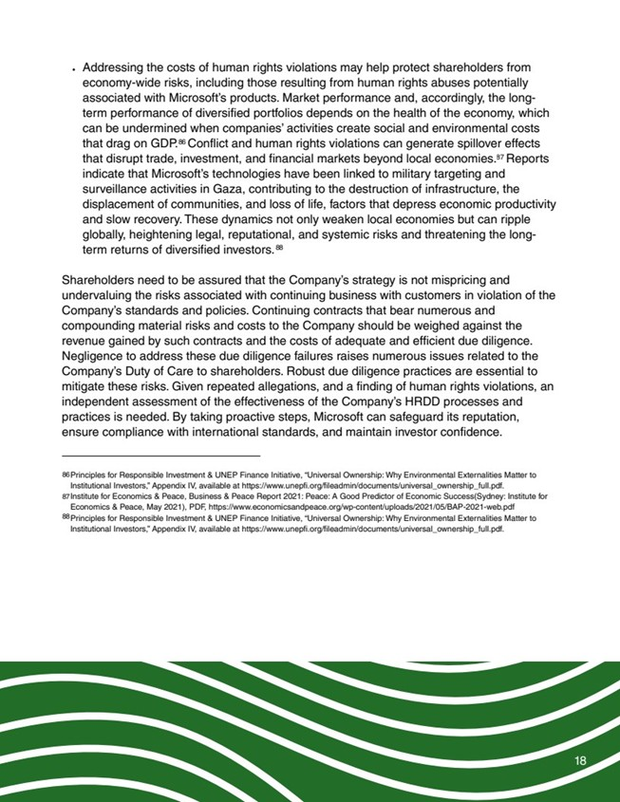
181818Principles for Responsible Investment & UNEP Finance Initiative, "Universal Ownership: Why Environmental Externalities Matter toInstitutional Investors," Appendix IV, available at https://www.unepfi.org/fileadmin/documents/universal_ownership_full.pdf. Institute for Economics & Peace, Business & Peace Report 2021: Peace: A Good Predictor of Economic Success(Sydney: Institute forEconomics & Peace, May 2021), PDF, https://www.economicsandpeace.org/wp-content/uploads/2021/05/BAP-2021-web.pdf Principles for Responsible Investment & UNEP Finance Initiative, "Universal Ownership: Why Environmental Externalities Matter toInstitutional Investors," Appendix IV, available at https://www.unepfi.org/fileadmin/documents/universal_ownership_full.pdf. Addressing the costs of human rights violations may help protect shareholders fromeconomy-wide risks, including those resulting from human rights abuses potentiallyassociated with Microsoft's products. Market performance and, accordingly, the long-term performance of diversified portfolios depends on the health of the economy, whichcan be undermined when companies' activities create social and environmental coststhat drag on GDP. Conflict and human rights violations can generate spillover effectsthat disrupt trade, investment, and financial markets beyond local economies. Reportsindicate that Microsoft's technologies have been linked to military targeting andsurveillance activities in Gaza, contributing to the destruction of infrastructure, thedisplacement of communities, and loss of life, factors that depress economic productivityand slow recovery. These dynamics not only weaken local economies but can rippleglobally, heightening legal, reputational, and systemic risks and threatening the long-term returns of diversified investors.Shareholders need to be assured that the Company's strategy is not mispricing andundervaluing the risks associated with continuing business with customers in violation of theCompany's standards and policies. Continuing contracts that bear numerous andcompounding material risks and costs to the Company should be weighed against therevenue gained by such contracts and the costs of adequate and efficient due diligence.Negligence to address these due diligence failures raises numerous issues related to theCompany's Duty of Care to shareholders. Robust due diligence practices are essential tomitigate these risks. Given repeated allegations, and a finding of human rights violations, anindependent assessment of the effectiveness of the Company's HRDD processes andpractices is needed. By taking proactive steps, Microsoft can safeguard its reputation,ensure compliance with international standards, and maintain investor confidence.868788868788

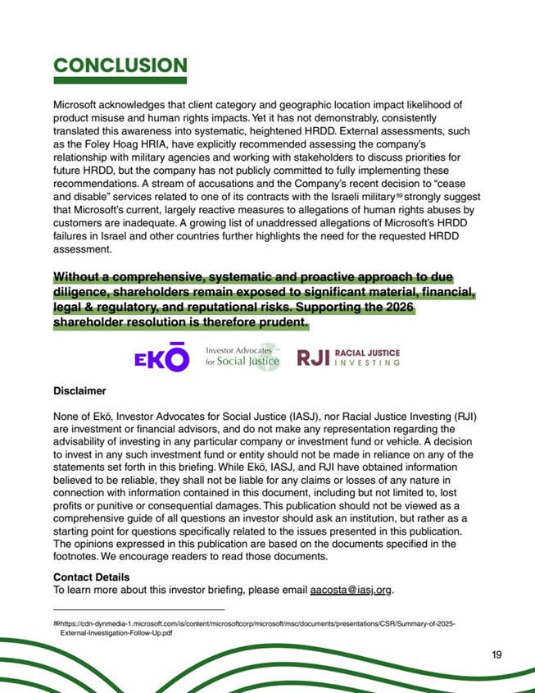
CONCLUSIONMicrosoft acknowledges that client category and geographic location impact likelihood ofproduct misuse and human rights impacts. Yet it has not demonstrably, consistentlytranslated this awareness into systematic, heightened HRDD. External assessments, suchas the Foley Hoag HRIA, have explicitly recommended assessing the company'srelationship with military agencies and working with stakeholders to discuss priorities forfuture HRDD, but the company has not publicly committed to fully implementing theserecommendations. A stream of accusations and the Company's recent decision to "ceaseand disable" services related to one of its contracts with the Israeli military strongly suggestthat Microsoft's current, largely reactive measures to allegations of human rights abuses bycustomers are inadequate. A growing list of unaddressed allegations of Microsoft's HRDDfailures in Israel and other countries further highlights the need for the requested HRDDassessment. Without a comprehensive, systematic and proactive approach to duediligence, shareholders remain exposed to significant material, financial,legal & regulatory, and reputational risks. Supporting the 2026shareholder resolution is therefore prudent.DisclaimerNone of Ek?, Investor Advocates for Social Justice (IASJ), nor Racial Justice Investing (RJI)are investment or financial advisors, and do not make any representation regarding theadvisability of investing in any particular company or investment fund or vehicle. A decisionto invest in any such investment fund or entity should not be made in reliance on any of thestatements set forth in this briefing. While Ek?, IASJ, and RJI have obtained informationbelieved to be reliable, they shall not be liable for any claims or losses of any nature inconnection with information contained in this document, including but not limited to, lostprofits or punitive or consequential damages. This publication should not be viewed as acomprehensive guide of all questions an investor should ask an institution, but rather as astarting point for questions specifically related to the issues presented in this publication.The opinions expressed in this publication are based on the documents specified in thefootnotes. We encourage readers to read those documents.Contact DetailsTo learn more about this investor briefing, please email aacosta@iasj.org. https://cdn-dynmedia-1.microsoft.com/is/content/microsoftcorp/microsoft/msc/documents/presentations/CSR/Summary-of-2025-External-Investigation-Follow-Up.pdf 198989

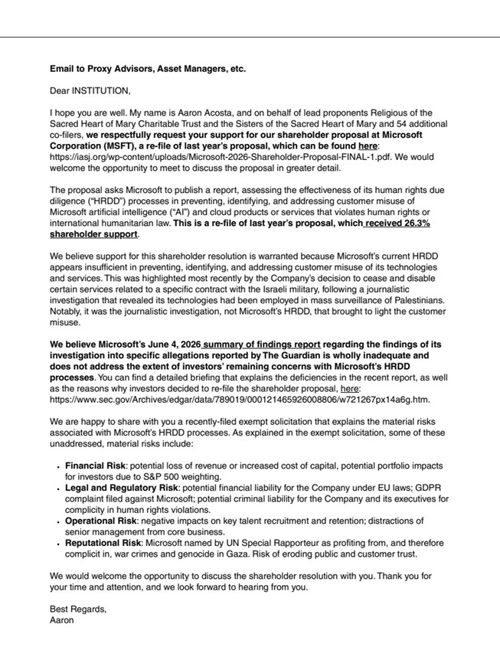
Email to Proxy Advisors, Asset Managers, etc.Dear INSTITUTION, I hope you are well. My name is Aaron Acosta, and on behalf of lead proponents Religious of theSacred Heart of Mary Charitable Trust and the Sisters of the Sacred Heart of Mary and 54 additionalco-filers, we respectfully request your support for our shareholder proposal at MicrosoftCorporation (MSFT), a re-file of last year's proposal, which can be found here:https://iasj.org/wp-content/uploads/Microsoft-2026-Shareholder-Proposal-FINAL-1.pdf. We wouldwelcome the opportunity to meet to discuss the proposal in greater detail. The proposal asks Microsoft to publish a report, assessing the effectiveness of its human rights duediligence ("HRDD") processes in preventing, identifying, and addressing customer misuse ofMicrosoft artificial intelligence ("AI") and cloud products or services that violates human rights orinternational humanitarian law. This is a re-file of last year's proposal, which received 26.3%shareholder support. We believe support for this shareholder resolution is warranted because Microsoft's current HRDDappears insufficient in preventing, identifying, and addressing customer misuse of its technologiesand services. This was highlighted most recently by the Company's decision to cease and disablecertain services related to a specific contract with the Israeli military, following a journalisticinvestigation that revealed its technologies had been employed in mass surveillance of Palestinians.Notably, it was the journalistic investigation, not Microsoft's HRDD, that brought to light the customermisuse. We believe Microsoft's June 4, 2026 summary of findings report regarding the findings of itsinvestigation into specific allegations reported by The Guardian is wholly inadequate anddoes not address the extent of investors' remaining concerns with Microsoft's HRDDprocesses. You can find a detailed briefing that explains the deficiencies in the recent report, as wellas the reasons why investors decided to re-file the shareholder proposal, here:https://www.sec.gov/Archives/edgar/data/789019/000121465926008806/w721267px14a6g.htm. We are happy to share with you a recently-filed exempt solicitation that explains the material risksassociated with Microsoft's HRDD processes. As explained in the exempt solicitation, some of theseunaddressed, material risks include:Financial Risk: potential loss of revenue or increased cost of capital, potential portfolio impactsfor investors due to S&P 500 weighting.Legal and Regulatory Risk: potential financial liability for the Company under EU laws; GDPRcomplaint filed against Microsoft; potential criminal liability for the Company and its executives forcomplicity in human rights violations.Operational Risk: negative impacts on key talent recruitment and retention; distractions ofsenior management from core business.Reputational Risk: Microsoft named by UN Special Rapporteur as profiting from, and thereforecomplicit in, war crimes and genocide in Gaza. Risk of eroding public and customer trust. We would welcome the opportunity to discuss the shareholder resolution with you. Thank you foryour time and attention, and we look forward to hearing from you. Best Regards,Aaron

